The system of taxation in the West Bank and Gaza Strip as an instrument for the enforcement of Authority during the Uprising

February 1990

This report was written by Hadara Lazar.

Acknowledgements are due to MK Haim Oron, Dr. Efraim Ahiram, Advocate Dan Simon of the Association of Civil Rights in Israel, Bassem 'Eid of B'Tselem, Advocate Avigdor Feldman, MK Dedi Zucker, Advocate Dr. Amnon Rafael, Al-Haq/Law in the Service of Man, The Hotline for Victims of Violence, and the Jerusalem Media and Communication Center.

English edition edited by Elliot Appel and Isabel Kershner.
B'Tselem would also like to thank Caroline Borup-Jorgensen for editing the English Internet Version of the report.

Translation by:
Elliot Appel
Ralph Mandel
Anna Orgal
Carmel Shalev

ISSN 0792-4003
"If I were to try to apply a portion of the measures I have used to step up collection of taxes in the territories within the boundaries of the green line, I would be hanged in Zion Square."

Mordechai Baraket,
Department Head,
Customs and Excise,
Ha'Aretz, October 31, 1989

Table of contents

INTRODUCTION 5
LEGAL PERSPECTIVE 7
Changes in Local Tax Laws 7
BUDGET OF THE TERRITORIES – REVENUES FROM TAX COLLECTION AND OTHER SOURCES 10
Ratio for Taxes to Gross Local Product 10
Other Sources of Revenue from the Territories 11
TAXATION DURING THE UPRISING 12
Payment of Taxes as a Condition for Receiving Services 12
Actions Illegal under Order No. 1262 15
Assessment by "Best Judgment" (Without a Statement) 20
Appeals 25
Raids 25
CONSLUSIONS 28
APPENDICES 31
APPENDIX A: Relevant Provisions of the Hague Regulations 31
APPENDIX B: Principals of the High Court of Justice Decision in the Case of Abu-Itta 33
APPENDIX D: Principles of Prof. Gerard Von Glahn's Expert Opinion on the High Court of Justice Ruling on the Abu Itta Case (69/81 493/8) 39
APPENDIX E: List of Orders Concerning Income Tax, Assessments and Collection (Judea and Samaria) 40
APPENDIX F: Letter from B'Tselem to taxation staff officer, and response 44
APPENDIX G: Letters from B'Tselem to Legal Advisor for the Judea and Samaria Region, and Response 46
APPENDIX H: Data on Principle Tax Laws in the Territories 49
APPENDIX J: Collection Data – Judea and Samaria Region Tax Years 1986, 1987, 1988 54
APPENDIX K: Order No. 1262 58
APPENDIX L: Petition of the Association for Civil Rights in Israel on Confiscation of Identification Cards 62
APPENDIX M: Letter from Adv. Dan Simon to Legal Advisor on Confiscation of Vehicle Licenses 65
APPENDIX N: Letter from the Hotline for Victims of Violence of November 7, 1989, and Response 66
APPENDIX O: Letter from Adv. Dan Simon to Head of Civil Administration on Arbitrary Demands for Tax Payment, Respone of Legal Advisor, and Response of Adv. Simon 67
APPENDIX P: Excise Added Tax – Regulation 115a 75
APPENDIX Q: Comparison of Tax Bracket Tables Under Jordanian and Israeli Law as Applied in the Occupied Territories 76
APPENDIX R: Testimony and Forms of Emil Uda Salameh 77
APPENDIX S: Testimony and Forms of Suhil Salem Hanuna 80

INTRODUCTION

This report deals with the system of taxation in the West Bank and Gaza Strip during the Intifada period. Its purpose is to examine changes made to the system over the past two years, a period which has seen a significant drop in the income of the residents, growing alienation between them and the government, and the launch of a widespread overt and covert tax rebellion.

In democratic countries, taxes are imposed by an elected government, giving the voters at least some feeling of control over the amount of tax they are expected to pay. In the case of a region under foreign military occupation, the residents cannot have any say in decisions concerning taxation. In such circumstances, the issue of taxation takes on special political significance, becoming a focus for friction between the occupier and the occupied. The former regards taxation as a legitimate means of financing the needs of the population, while the latter perceives it as oppressive and coercive. The occupying government should, therefore, exercise extreme caution and discretion with respect to fiscal measures.

This report attempts to answer the following questions:
1. Are actions being taken which contravene legal regulations and orders?
2. Do the tax laws applied in the territories comply with the spirit of the law?
3. What are the measures employed to enforce the tax laws?
4. What are the results of such enforcement?

The report briefly surveys the legal aspects of tax collection in the territories, with reference to the pertinent provisions of international law and to the changes implemented in the local law of the West Bank and Gaza Strip under Israeli rule.

The report goes on to present background data on the budget of the occupied territories, tax revenues, and the ratio of taxes to GNP.
The report primarily addresses the situation vis-à-vis taxation which has arisen in the wake of the uprising. It describes the system of tax collection in use since the start of the uprising and the measures employed to maintain it. Some typical cases have been selected from documented complaints to illustrate the way the system works. Finally, the norms of enforcement and appeal in force in the territories are compared with those in use in Israel.
The report does not purport to deal with the entire range of fiscal matters in the territories. Rather, it aims to examine the use made of taxation in the territories, and to indicate the policy, objectives, and use of taxation in a situation of popular insurgency.

The report does not deal with the following topics:

1. The amount and designation of social security deductions from the salaries of residents of the territories working in Israel, which have accumulated over the past 22 years in a special "deduction fund."∗
Despite many attempts to obtain information about this fund, details on the accumulated sums and their use were not made available to us. Similar attempts in previous years to obtain information about this substantial fund have been just as unsuccessful. This information is not public.

2. A full comparison between methods of tax collection used in the territories before the uprising and those used over the past two years cannot be made, because the Civil Administration failed to respond to our written and oral inquiries on this matter.

3. Although the law in the territories provides for appeals on the assessment of income tax and excise added tax, we were unable to evaluate the functioning of the appeal mechanism as we did not receive answers to our questions regarding the frequency with which the review boards convene, the officials who serve on them, and the number of appeals heard, or pending hearing.

For assistance in preparing the report, acknowledgements are due to MK Haim Oron, economist Dr. Efraim Ahiram, Advocate Avigdor Feldman, MK Dedi Zucker, and Advocate Dr. Amnon Rafael. Al-Haq/Law in the Service of Man provided extensive background material. The State Revenue Administration prepared data for B'Tselem on tax collection and the ratio of taxes to the GNP. Testimonies and affidavits were gathered from the beginning of July until the end of December 1989. Most of the examples presented in the report are from the West Bank. An Israeli, previously employed at the customs station at the Erez checkpoint in the Gaza Strip, gave detailed testimony as to the practices there. Parts of his testimony are quoted in the report.

LEGAL PERSPECTIVE

With the establishment of the Military Government in the West Bank and Gaza Strip in 1967, all the powers of the previous government passed into its hands. This action is in accordance with the principles of international law, its purpose being to ensure the proper administration of the daily life of those resident in a territory occupied by a foreign force. However, international law and the particular laws of war regarding taxation provide only general guidelines, leaving the rest to the discretion of the government. Under customary rules of international law (the Hague Regulations), the Military Commander has a duty to respect the laws in force in the territory at the time of occupation. These laws may be changed only as necessitated by considerations of military security or public safety.

Decisions of the Israeli Supreme Court have held that the Israeli occupation of the territories has endured far longer than any occupation contemplated by the drafters of the rules of international law. The regional IDF commander may, therefore, amend local laws to adapt them to such fundamental changes in living conditions as occur over the course of a prolonged occupation, as long as the amendments are for the benefit and welfare of the local population. The Court also permitted and justified the introduction of a value added tax (the excise added tax, as it is called in the territories) on grounds of the need to achieve equilibrium between the economic system in the territories and that inside Israel.

The legislative orders of the Military Government are issued by the respective IDF commanders in the region of Judea and Samaria or the region of the Gaza Strip. Military legislation does not require the signature of any member of the Israeli cabinet or the approval of any Israeli parliamentary committee. By the nature of things, there is no process of consultation with the residents. The local residents have neither representation nor any other means of expressing their views as to the need for legislation. It therefore falls upon the military commander of the region to represent the residents and to serve their best interests. This is not an easy task, since it requires a significant degree of understanding and involvement in day-to-day life in the region.

The only mechanism for reviewing the legislative orders of the military commanders is that exercised by the Israeli High Court of Justice. This court intervenes only in rare instances, normally abstaining from substituting its judgment for the discretion of the military commanders.

Changes in Local Tax Laws

Over the course of its 22-year occupation, Israel has implemented many changes in the tax laws of the West Bank and Gaza Strip. Most of the amendments related to changes in interest rates, debt indexing, and tax collection, but they were rarely applied in practice. In effect, the Military Government allowed residents of the territories to continue acting according to local practice. It refrained from enforcing unfamiliar norms on a population which, as an occupying power, it was not bound to educate in fiscal matters. Most of the residents paid extremely low income tax, or none at all (in the West Bank the Jordanian income tax law of 1964 applied, while in the Gaza Strip the applicable law was the income tax ordinance enacted under the British Mandate in 1947). Except for large companies which employed accountants, tax collection in the territories was mainly a matter of negotiation between the authority and the taxpayer. Tax assessments were not based on written data, but were the result of settlements reached with both parties' consent.
In 1976, when a value added tax (VAT) was introduced in Israel, the same law was extended to the territories by means of an order known as "Excise Added Tax"¯ (EAT), which attached the new tax to the excise tax already established under Jordanian law. In 1981 the authorities attempted to enforce the law more vigorously, requiring businesses in the territories to keep books and submit tax statements. That same year, eight residents of the territories - four from the West Bank and four from the Gaza Strip - petitioned the High Court of Justice on this matter. The Court gave a long reasoned decision, known as the Abu Itta case, dismissing the petitioners' challenge to the legality of the EAT imposed in the territories. The Court ruled that new taxes could be imposed in occupied territories under the rules of international law, if necessary to maintain public order. Nevertheless, most amendments to the tax laws were not actually implemented prior to the uprising.

Taxes Imposed in Israel

Income tax
Value added tax
Land appreciation / property tax
Customs and excise tax (excise - fuel, tobacco, methylated spirits, cement)
Employers tax
Property tax and compensation fund
Purchase tax
Stamp duty
Travel tax
Levy on imported services
Levy on property
Levy on foreign currency purchase
Levy on foreign currency credit
Levy on appreciation

Taxes Imposed in the West Bank and Gaza Strip

Income tax
Education tax (West Bank only)
Land tax in rural areas (West Bank only)
Land tax in urban areas (West Bank only)
Customs
Excise added tax (corresponds with value added tax)
Travel tax (applies under Israeli law to persons exiting from Israeli ports)
Stamp duty
Levy on imported services and assets (under Israeli law)
Levy on vehicles

Fees - business licensing, health insurance, passage over the Jordan bridges and through the Rafah terminal, various licenses (e.g., driving)

BUDGET OF THE TERRITORIES – REVENUES FROM TAX COLLECTION AND OTHER SOURCES

Revenues from taxes paid by residents of the territories pass directly into the budget of the Civil Administration. The governmental system in the territories is separate from that in Israel, and is financed mainly by the taxes collected in the West Bank and the Gaza Strip.
Israel's contribution to the budget of the Civil Administration has decreased over time, due in part to the broadening and intensification of tax collection. In the years immediately following the 1967 war, the State's share in the budget of the territories amounted to almost 100%, whereas in recent years it has fallen to between 7% and 9%. Even this amount is financed indirectly by residents of the territories through income tax deducted from the salaries of those employed in Israel, as is generally required under the law. Israel's contribution to the budget of the territories does not, however, account for all taxes collected in this way. According to figures calculated in 1987 for a Knesset subcommittee discussion on the budget of the Civil Administration, the budget had an annual surplus of between 10 and 20 million U.S. dollars, taking into account income tax collected from salaries of residents of the territories employed in Israel.

Revenue from the territories themselves constituted 82% of the budget for the 1989/90 fiscal year. The social security "deduction fund" contributed 9%, and, as already noted, Israel's allocation to the budget of the territories also constitutes 9% of the total. The budget for the West Bank and Gaza Strip in 1987/88 and again in 1988/89 was NIS 486 million. In the wake of the Intifada, tax collection was forecast to decrease. Nevertheless, the sum collected exceeded the forecast by NIS 70 million in 1988, and by NIS 40 million in 1989, creating a surplus of NIS 110 million. From this, the sum of NIS 54 million was actually transferred to the budget of the territories. The remaining surplus, amounting to NIS 56 million, was designated for use in either the current or the coming fiscal year.
These figures provide further evidence that a surplus has accumulated in the Israeli treasury, a fact already known to members of the Knesset subcommittee in 1987. At the same time, however, the Israeli authorities have been claiming that a decrease in tax revenues during the Intifada has obliged them to cut back public services. For instance, this was the official reason cited for cutting down admissions of residents of the territories to hospitals in Israel.

Ratio for Taxes to Gross Local Product

Figures on the ratio of taxes to gross local product in the territories∗ show that:

a. The West Bank belongs to the tax payment bracket of less developed countries, where between 2% and 5% of GNP is paid in the form of direct taxes.

b. Per capita income in the West Bank is the highest of all these countries.

State Revenue Administration data on tax collection in the territories also support these conclusions.∗

Other Sources of Revenue from the Territories

As mentioned above, we encountered severe difficulties when inquiring about social security deductions accumulating in the special "deduction fund" in Israel's treasury. For a resident of the territories employed in Israel, 16% of his or her salary is set aside for social security (10.85% paid by the employer, and 5.35% by the employee). At the same time, workers from the territories actually benefit from only one eighth of the sum set aside for them, because they are entitled to only four of the categories of insurance rights provided by social security:

1. work-related accidents
2. bankruptcy
3. maternity (this category is taken advantage of rarely)
4. retirement pension (this category is taken advantage of rarely)

None of the other categories of social security rights apply to residents of the territories. These include pensions for senior citizens, widows, children and survivors, and insurance for general disability and unemployment. The monies set aside for these categories over the past 22 years have been accumulating, as mentioned, in the deduction fund. We know that other attempts, including those by Knesset members, to obtain clear information about the accumulated sums and their designated use have been unsuccessful.

The fact that accurate and verifiable information is unavailable in itself raises several questions and conjectures: Why is this matter kept secret? Is the money being used in Israel? Why is it not transferred to the territories? How much money has accumulated? Some claim that the sum is on the order of hundreds of millions of shekels, some say billions, and others say much less. Only a public, authorized account of the figures dating back to 1967 can refute the claims and suspicions.

TAXATION DURING THE UPRISING

For all practical purposes, the system of tax collection in the territories collapsed with the collective resignation of the local employees of the Civil Administration. Israeli employees, most of whom did not have previous training or experience, were recruited in their place. These officials are dealing with residents whose income has decreased significantly and who have never kept books; many of them have refused to pay taxes since the start of the uprising, either as an act of civil disobedience or for fear of retribution. The tax officials carry out their field work - business inspection, debt execution, etc. - under military escort. They are expected to enforce legislative orders that were never previously implemented, as well as new orders. Two of the new orders are worth noting:

The Order Concerning Tax Collection (Ancillary Powers) (No. 1262) was enacted on December 17, 1988. It conditions the issue of licenses and provision of services on payment of taxes. We shall elaborate below on the manner in which this order is applied.

The Order Concerning a Special Levy on Vehicles (according to variables such as value and model) (No. 1249) was enacted on August 17, 1988. This order has been nicknamed "the Intifada law" in the territories. Section 10A empowers any police officer or authorized soldier to impound a vehicle if the owner is suspected of having failed to pay the levy.

The tax officials have also employed new methods of collection (raids, roadblocks and special operations). All this has created a new situation in which, as things stand, incidents such as those described below are likely to occur quite frequently. Cases presented in this report are typical. Each case is characteristic of a certain sort of confrontation between the tax bureaucracy and local residents. Each is one of many similar documented or undocumented cases.

Payment of Taxes as a Condition for Receiving Services

Section 2(a) of Order No. 1262 provides:

"Any person authorized to provide a license or service under a provision of the law or security legislation listed in the Appendix may make provision of the service or the license, including its renewal, contingent on submission of evidence that the applicant has performed all actions imposed on him under any tax law, and has paid the tax that he owes at that time."

This order applies to 23 matters, encompassing almost all areas of daily life in the territories:

1. Personal permits to leave the region, under section 90 of the Order Concerning Security Provisions.
2. The Press and Publications Law, No. 16, 1967.
3. The Trade Licenses Law, No. 89, 1966.
4. The Trades Law, No. 16, 1963.
5. The Application Scribes Licensing Law, No. 42, 1966.
6. The Accountancy Profession Occupation Law, No. 19, 1961.
7. The Authorized Surveyors Licensing Law, No. 7, 1948.
8. The Insurance Business Control Law, No. 5, 1965.
9. The Order Concerning Prohibited Occupations (Judea and Samaria), No. 65, 1967.
10. Licenses for Mining and Quarrying under the Natural Resources Regulation Law, No. 37, 1966.
11. The Town, Village and Building Planning Law, No. 79, 1966.
12. The Antiquities Law, No. 51, 1966.
13. The Tourism Law, No. 51, 1965.
14. The Telephone Regulations, No. 1, 1951.
15. Provisions concerning the Establishment and Control of Industrial Plants, No. 1, 1966.
16. Vehicle and drivers' licenses, and registration of transferal of ownership of vehicles, under the Road Transportation Law, No. 49, 1958, or the Order Concerning the Transportation Law (Traffic Regulations) (Judea and Samaria), No. 399, 1970.
17. Personal permits under the Order Concerning Bringing Money into the Region (Judea and Samaria), No. 973, 1981.
18. The Companies Law, No. 12, 1964.
19. The Trade Names Registration Law, No. 30, 1953.
20. The Trademarks Law, No. 33, 1952.
21. The Order Concerning Transferal of Goods (Judea and Samaria), No. 1252, 1988.
22. Personal permits under the Order Concerning Currency Control (Judea and Samaria), No. 952, 1981.
23. The issue of license plates for vehicles under Appendix IV to the Road Transportation Law, No. 49, 1958.

For every application relating to any of these 23 matters, the applicant must fill in a "travel" form for which he is required to obtain the stamps of seven authorities:

1. The police
2. Income tax - the stamp is conditional on full payment of tax
3. Excise added tax - the stamp is conditional on full payment of tax
4. Civil Administration
5. Municipality
6. Ministry of Interior - the Villages Association
7. Property tax

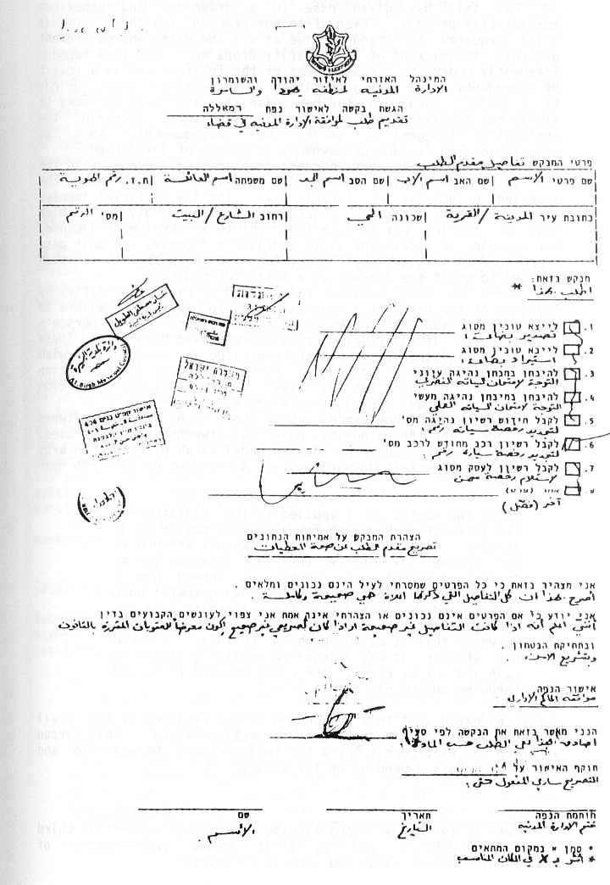

All this has given rise to a drawn-out and cumbersome bureaucratic process. Even if things proceed smoothly, one is still required to stand in line at all the different government offices. If any kind of irregularity crops up - and this happens frequently under the circumstances of the Intifada and as a result of dependency on so many authorities - the entire process grinds to a halt. Then, in the best case, the applicant is lucky to simply not receive the service. In the worst scenario, the application triggers a series of consequences, such as restrictions on freedom of movement or source of livelihood.∗

Order No. 1262 vests extensive administrative powers in the tax authorities which would not withstand review under the accepted principles of Israeli law. The law in Israel imposes certain relevant duties and procedures on the individual which must be carried out to gain the right to a service or license. For example, if a resident wants a driver's license, she must pass a proficiency test and pay the set fee, and the authority is then obliged to grant the license as a matter of course.

Order No. 1262 violates this system of rights and duties by imposing on the resident a "supreme" duty to pay taxes. Failure to fulfill this "supreme" duty entails forfeiture of a person's rights, even if all relevant requirements have been met. These extreme administrative powers are exercised in conjunction with the unusually harsh mechanisms for enforcement and collection already existing under the tax laws. This one-sided situation leads to the unfair denial of services and licenses.
Under these circumstances, where there is no dialogue between the resident and the authority, paid "go-betweens" are often used. Consider the testimony of Jassan Abdul Wahab el-Hatib, an arts instructor at Bir-Zeit University, and a resident of El-Bireh near Ramallah:

About two months ago I applied to the Ministry of the Interior in Ramallah for a laissez passer to go abroad. I got a "travel" form. When I arrived at the income tax office the clerk asked me for my three most recent pay checks. I showed him a letter from Bir-Zeit University proving that I work there, and explained that the university pays its employees in cash and not by check. The clerk answered that it was my problem, not his. I asked him whether it was illegal to receive a salary in cash and not by check. The clerk shouted at me and threw me out of his office.

Jassan el-Hatib went to a person who is not employed by the Civil Administration, but has good connections there. This person arranged the exit permit for a fee (which ranges between 50 and 100 U.S. dollars depending on the case).

It is doubtful whether this bureaucratic process complies with standards of international law, since it cannot be justified in terms of the security or welfare of the population, and does not serve the purpose of achieving equilibrium between economic conditions in the territories and those inside Israel. In Israel, measures such as these are not used and would probably be considered illegal. Last year the Ministry of Transportation decided to condition the renewal of driving licenses on payment of fines for parking offences. Following a public uproar, Minister of Transportation Moshe Katzav announced that the two matters concerned separate and distinct services and should not be connected.

Actions Illegal under Order No. 1262

At times, the Israeli authorities exceed even the broad powers vested in them by Order No. 1262, and condition the issue of licenses or other official documents on payment of taxes, even when not so required by the law.

The case of Ahmed Abu Ida, of Bethlehem, is an example of this blatantly illegal activity, which is by no means rare in the territories:

On April 5, 1988, a daughter was born to Abu Ida. When he came to register her and get a birth certificate, he was told that first he needed to get stamps from the seven government offices. At the income tax office he was refused the required stamp because of outstanding arrears. The debt was assessed at NIS 900. Abu Ida claimed he was a salaried employee, and that his taxes were deducted from the salary by his employer. After a while, Abu Ida's wife filled in an identical form under her own name, and obtained the stamps of the seven authorities. The birth certificate was then duly issued.

Order No. 1262 does not make the issue of a birth certificate contingent on payment of taxes.

Conditions of Services on Payment of Third Party Arrears

Receipt of a license or document is frequently conditioned on payment of tax arrears owed by a third party, as described in the testimony given by Saleh Ata'out to B'Tselem:

On July 5, 1989, Saleh Musabeh Ibrahim Ata'out, a resident of the West Bank, entered the territories with his wife and five children. For the past 14 years he had been living in Saudi Arabia, and he was now on a visit to his family in El-Bireh. When he wanted to return to his place of residence, via Amman, he was refused an exit permit because of a debt owed by his father. He was told that his father owed arrears to the tax authorities. The father, Musabeh Ibrahim Ata'out, has been employed for the past six years at "Mipromal", a copper plant in Givat Sha'ul in Jerusalem. He produced a letter from his employer confirming that all deductions had been made each month from his salary. The Civil Administration refused to accept the letter and demanded that he pay the debt. We did not examine the grounds for the payment demand. What concerned us was the son's right to receive an exit permit, regardless of the father's debt. The son was told that he would not receive the permit so long as the debt remained unpaid. Under the law of Saudi Arabia, the mother and children cannot return without the father. Because the smallest daughter suffers from a kidney disease for which she receives treatment in Saudi Arabia, Saleh Musabeh Ibrahim Ata'out paid the sum of NIS 683.84, claimed to be his father's tax arrears, and then left the country.

Conditioning a service on payment of a third party debt is not legal under the orders in force in the territories, and is not practiced inside Israel.

Confiscation of Identification Cards

Confiscation of identification cards to force people to pay their taxes has become a matter of routine since the beginning of the uprising, despite it being an illegal action. This practice is reported repeatedly, and some of the cases are described below. Since residents avoid contact with the authorities as much as possible, one may assume that some of the accounts would never have reached us had the cards not been confiscated. The identification card is essential to a resident of the territories precisely in circumstances such as these. Consider the testimony of Thalaj Abdalla Daoud Sawafta, given by sworn affidavit to an attorney:

1. I am a resident of the village of Tubas. I am about 70 years old. I retired from work over ten years ago, and since then I have not worked.
2. On June 3, 1989 a curfew was imposed on the village. Soldiers came to my house and asked for my son Fuad. Fuad lives in the house one floor above my own and was not home at the time. I told them Fuad was not there.
3. They took my identification card and ordered me to go to the Civil Administration. They asked where my son was. I answered that he was at work. They told me to come back the next day.
4. The next day, on June 4, 1989, the income tax clerk told me my identification card would be returned after I brought my son Fuad to the office in Jenin because Fuad owes money. I answered I was not prepared to do so, and I told them they should look for Fuad themselves.
5. I was given a permit for movement without an identification card effective until June 10, 1989.
6. On June 12, 1989 I went to the Civil Administration in Tubas and asked for my card. They told me the authorized clerk was not there.
7. Today, I was on my way to see the doctor at 7:30 am, when I was stopped at an IDF roadblock. A soldier asked for my identification card [...] He did not let me through the roadblock because the permit was no longer in effect. The soldier confiscated the permit. I asked him to return the permit so I could return to Tubas, but he refused and hit me in the face. I went back to Tubas to the Civil Administration office where they refused to return my identification card, but renewed the permit until June 20, 1989. They repeated their demand that I bring my son Fuad.
8. I am afraid to leave my house without an identification card.

Confiscation of Identification Cards for Third Party Arrears
Identification cards are often confiscated for tax arrears owed by a third party. The following is a letter from Attorney Aliza¯Herman to the Judea and Samaria Legal Advisor, dated June 22, 1989:

On May 15, 1989 the identification card of Wassam el Aziz Musaleh (an 18 year old high school student) was taken from him on the grounds that his father owes income tax. When he went to the Civil Administration on May 16, 1989 to clarify the matter, he was told by Lieutenant Adam Dunsky that he would receive his identification card after he, his father, or any other person paid the arrears.
Wassam has been without an identification card for almost a month and a half. It is unnecessary to describe the situation of a person, a resident of the territories, who does not have an identification card. On June 18, 1989 he was arrested by soldiers, after they asked him to identify himself and he did not have a card.
For a week we have been trying to talk to Lieutenant Adam on the phone to ask that the identification card be returned, but we cannot locate him, and he has not bothered to contact us in response to our numerous messages.

Finally, on June 29, 1989, following additional conversations with various officials, Wassam Musaleh came to the Civil Administration offices in Ramallah, accompanied by an Israeli Arab, and received the identification card.

The confiscation of an identification card because of tax arrears is not legal under the taxation orders, and is certainly illegal when the arrears are owed by a third party. The Order Concerning Security Provisions expressly states the conditions and restrictions under which a person's identification card may be taken from him. This is clearly forbidden for the purpose of enforcing tax payment.

Following a petition to the High Court of Justice by the Association for Civil Rights in Israel on behalf of several residents of the territories, the IDF presented an order concerning the conditions for confiscating identification cards. The order was issued on May 25, 1989 by the OC Central Command. Nevertheless, confiscation of identification cards and conditioning their return on payment of taxes continues, in violation of the judgment of the court in HC 278/89 and the military order (see Appendix L).

Measures such as these have never been used inside Israel.

Confiscation of Vehicle Licenses

Shortly after the petition concerning confiscation of identification cards was presented, the authorities started confiscating vehicle licenses for non-payment of taxes. This measure has also been used extensively as a matter of routine.
Hussen Ali Muheissen was driving his private car on July 5, 1989 from Ras el Amud to Jericho. While passing through El Azariya he was stopped by a Border Police jeep, and told to follow it to Kedar junction. There he was told to park his car and go over to a lot where many people were gathered. Income tax officials were seated at a table there, and he was sent to them. When asked whether he was employed, he answered that he was a student. "They did not check any book or list, or make any calls," he recounted in his complaint, "but in a totally random and arbitrary fashion told me that I owed NIS 800, and they noted that even though I do not belong to their area, they would oblige me to pay income tax. The income tax official took my vehicle documents. They gave me a payment slip in the amount of NIS 800 and told me to go pay and be back by 11:00. If I did, I would get my papers back. There were about 200 people there at that time, and I saw them also taking papers from other people and charging them with debts. I want to note that I did not appear on any list of theirs. They arrested me by chance because I was passing through the Azariya area...." Hussen Ali Muheissen did not pay the money demanded of him, preferring to leave the car parked near his home.

On July 20, 1989, following this and similar complaints, Attorney Dan Simon of the Association for Civil Rights in Israel wrote a letter to the Judea and Samaria Legal Advisor, claiming that confiscation of vehicle licenses is illegal under the Order Concerning Tax Collection (see Appendix M).

These measures have never been employed in Israel.

Aside from the confiscation of the vehicle license, the above case also involves an arbitrary demand for tax payment, without any relation to the person's place of residence or economic situation. This also occurs frequently, in the course of other activities. This kind of arbitrary policy is not practiced in Israel.

There have been some instances of confiscation of identification cards and vehicle licenses together. For example, on August 10, 1989, Raad Farid Elias el-Tawil, of Beit Sahour, parked his car near his father's store:

Soldiers arrived and asked for the vehicle licenses. I gave them the papers and they asked me to follow them to the [Civil] Administration. Two days later I went to the income tax [office] without my car, and there they asked me for my identification card. I gave it to them. They said, bring your car. A week later I went to the income tax without my car. They asked me why I didn't bring the car. I said, this car is mine and if my father owes you tax payments go and ask him to pay. They refused to give me the card. Two days later I went to the [Military] Government. I told them that the income tax had taken my identification card. At the Government they said I had to have a "hiking" form to get new papers. I did so, and when I went to the income tax for their stamp, they tore up the form and told me I had to write a letter that I had forgotten the identification card at the income tax [office]. I wrote the letter. Two days later I went to get a new identification card, and found a summons to the village officer Yossi. I went, and Yossi told me he had my identification card but I could not have it until my father paid his income tax arrears. In the end he gave me the card on condition that I go to the income tax. I did not, and the vehicle licenses are still being held at the Civil Administration.

Attachment of Vehicles

One of the main grounds for attachment of vehicles, an extensively used measure, is non-payment of the uniform tax that is imposed indiscriminately on all the vehicles in the territories. The Hotline for Victims of Violence wrote a letter to the Hebron Civil Administration, requesting the reasons for confiscation of the private car of Maher el Hajuj, who works as a teacher and not as a taxi driver. The official response, dated November 19, 1989, stated: "In relation to your question about the above vehicle, a uniform tax has been set for all vehicles, since it is known that all the vehicles on the West Bank are used to transport paying passengers."

Assessment by "Best Judgment" (Without a Statement)

Assessment by "best judgment" is used by law when no statement has been filed. Since most of the taxpayers in the territories do not keep books, both income tax and EAT are assessed for them by "best judgment." This process is based on negotiations between the taxpayer and the tax officer, leaving the assessment in the hands of the officer.

Aids designed to assist the officer in making assessments do not fit the new conditions of life in the territories. Calculations prepared by the Income Tax Commission and Customs Department did not take into account changes since the start of the Intifada: a sharp decrease in income, a decrease in economic activity, surplus income, and consumption of services and products, as well as depreciation of the Jordanian dinar (for a long time the exchange rate was calculated at NIS 6 when in reality it was NIS 3). None of these factors are reflected in the calculations.

Tax brackets were set for the territories in 1988. According to international law the occupying power must preserve local law unless changes are required for the benefit of the residents or in the interests of public order. The tax brackets are an amendment to previously existing local law. Appendix Q compares the tax burden on a family with four children under Jordanian law with the burden under the new Israeli scheme.

The comparison shows that between 1987 and 1988 there was a 14% nominal and 16.5% real decrease in deductions from taxable income. At the same time the tax brackets were raised. The combined effect of these two actions was a significant rise in the general scope of taxation, especially with regard to large low income families. Since this change occurred in 1988, that is, after the start of the uprising in the territories, it can be interpreted as a measure of collective punishment.

An assessment includes tax differentials, fines, interest and linkage, and can therefore range from thousands to tens of thousands to hundreds of thousands of shekels. During negotiations over assessments, settlements are reached at the rate of 40%-60% of the original assessment. These figures raise doubts as to the credibility of the original assessment.

This matter is mentioned in the 1986 Report of the State Comptroller:

The handling of possession cases entails varied and complex professional actions, carried out by committees headed by the Staff Officer or his deputy. The documents show that a significant number of files were concluded by settlements with the taxpayer, while conceding large sums in their favour, compared with the original assessment. The Comptroller noted that it may be advisable to examine whether the need for settlements does not stem from insufficiently founded original assessments, in which case there might be need for further training of the professional workers who make the assessments. If the Civil Administration believes that the basis for the original assessment is sufficiently strong, collection of the sums determined in the original assessments should be insisted upon more forcefully.

Since it is impossible to establish the facts, the assessment has become a matter of bargaining between the taxpayer and the authorities. The impression is that the authorities have used this bargaining procedure very effectively, as an instrument of their authority, to put pressure on taxpayers for purposes unrelated to tax collection.

It is very simple for an authority to make a high assessment. Indeed, it is the policy of both income tax and EAT to do so, and there is nothing unlawful about it. In Israel, as well, high assessments are made where there is no statement, but they are cancelled once a statement is filed. Because statements are not filed in the territories, the high assessment remains in force, and it is usually far higher than what would have been set in Israel under similar circumstances.

Often the taxpayer is a small unregistered business, or a salaried employee who works for an unregistered employer. Taxpayers such as these form a large portion of the residents of the territories, and they face the assessment process without protection. They have never kept books or filed statements. Many have never paid taxes. In the usual case there are no negotiations with the tax officer. The assessment is simply set. And in the usual case, these taxpayers do not bargain or appeal, but accept the consequences (confiscation of documents and property, or detention) just as they accept other governmental decrees.

On September 26, 1989 a curfew was imposed on Bir Naballa. All the men were taken from their homes to the school yard where a concentrated tax collection campaign was carried out. Marwan Abu Ta'ah testified that he was required to pay 1,450 dinar, and was told that if he did not do so his home would be sealed. He claimed that he had closed his soldering shop at the beginning of the Intifada, had been working on an hourly basis at odd jobs approximately ten days a month, and did not therefore owe any tax. ¯His identification card was taken from him, and he was given substitute papers that expired on September 30, 1989. This is where the familiar story begins of the resident without the identification card who enters a long drawn-out encounter with the tax authorities.

Sometimes the assessment is totally untenable. On June 27, 1989 a curfew was imposed on the A'ida refugee camp near Rachel's Tomb in Bethlehem. Abd el Majid Hamad Abu Sarur, the owner of a small grocery store, received an EAT assessment in the amount of NIS 500,000. During a search of his home the following sums were discovered and confiscated:

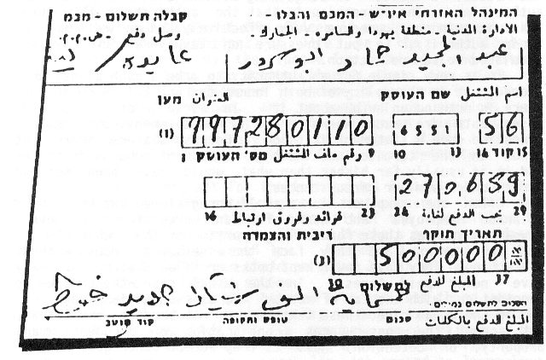

10,088 dinars, 703 dollars, and 900 shekels. Abu Sarur told the Administration officials conducting the search that these sums were his children's savings, but the money was taken pending investigation. At the Bethlehem tax offices he said that he was unable to read or write, and that since 1967 the residents were never required to pay taxes. In response he was told that the government is now insisting on payment of taxes. He was asked to sign a payment slip (the date for final payment, written in Arabic on the bill, was June 27, 1989, the same day on which he received the assessment). He signed without understanding. Only when he arrived home did his children explain to him that he had been given an assessment for half a million shekels on a small grocery store in a refugee camp.

An assessment by "best judgment" should indeed involve the use of judgment. Various considerations must be weighed until a conclusion is finally reached through the logic of the system. Assessment by "best judgment" is not arbitrary, and it should not ignore the reality of a given situation. In this respect, assessment by best judgment differs in Israel and the territories. In Israel it is based on calculations, on statements of other taxpayers, and on an economic reality with which the tax authorities are very familiar. In the territories, however, some of the collectors perceive assessment by best judgment as a means of punishing the residents of the occupied region, or at least as a "determination" (as it is called there) imposed on the taxpayers without any communication or appeal on their part.
Considering the above, the fear expressed by the petitioners in the Abu Itta case, that enforcement of the EAT would harm rather than benefit the economic conditions of the Palestinian population, appears to have been realized.

Attachments

As a consequence of the excessive assessments, attachments are placed on the businesses, property, and homes of taxpayers. The value of the attached assets is at least twice as high as the assessment, because they are sold in public auctions at 40%-50% of the consumer price. In addition, the costs of transportation and storage are taken into account.

Makram Yusef Sa'ad, the owner of a Bethlehem pharmacy, stopped filing tax statements in 1988. On February 2, 1989 - following a series of confrontations with income tax and EAT authorities, the confiscation of his car and some of the stock from his pharmacy, and being detained several times for interrogation∗ - he received an EAT assessment to the amount of NIS 150,000, including the fines, interest and inflation factor calculated on the base assessment. Prior to the uprising, Sa'ad paid EAT to the annual sum of NIS 2,400. He refused to sign the assessment, and an attachment was subsequently placed on part of the pharmacy stock. On July 12, 1989 the entire inventory of the pharmacy was attached. Sa'ad testified that the enforcement officials took all they could find without leaving any written record. Items that fell on the floor were trodden on intentionally. The stock - which Sa'ad claimed was worth approximately 60,000 dollars - was placed in an iron container on a plot near the Atarot airfield. It is still there, but has lost its value, because the expiration dates on some of the medicines have passed, and most of the drugs and cosmetics have been destroyed by the high temperatures (40-50°C) that accumulated in the container under the hot summer sun.

High assessments, large-scale attachments, and general indifference have become a matter of routine and recurrence:

On October 16, 1989, at 10:00 am, a reinforced unit of soldiers (sometimes the collection or enforcement officers wear military uniforms) entered a leather bag store in the Anbatawi building in Nablus, which belongs to Mazhar Atef Tawfiq el Hayat. He left the store open and ran away. Two and a half hours later the store was empty. The soldiers did not leave any attachment form. According to el Hayat, the value of the attached merchandise was between NIS 100,000 and 120,000. He said: "I did not go to inquire about the affair. From the beginning of the Intifada I have not paid any taxes. Before the Intifada I used to¯pay EAT to the monthly amount of NIS 50. I do not want to go to the [Civil] Administration."

The policy of high assessments is not practiced inside Israel. There, both assessments and attachments are made on the basis of relevant facts, and are not accompanied by actions such as those described above and below.

Special Operations, Roadblocks

All the measures already described - confiscation of identification cards and vehicle licenses, excessive assessments, and attachments - are taken concurrently in the course of special operations or at roadblocks. They converge to form a web which is woven around the resident of the territories. Consider, for example, the testimony of AH - an Israeli who was employed for some time as a customs officer in Gaza after the local employees resigned from their positions in February 1988 - about the special operations and roadblocks in the Gaza Strip.

In June 1988 an operation was launched, to change and replace the identification cards of the entire population of the Gaza Strip. In order to receive a new card, the taxpayer was required to fill out a "travel" form. If the computer (not the assessment required by the law) showed any tax arrears, he was given a "debtors" form which had to be stamped to prove that he did not owe any taxes. Long lines formed in the heavy summer heat outside the customs and income tax offices. Persons found to owe taxes were given assessments and required to pay additional fines and interest. Some assessments were made by agreement, without explaining to the taxpayer that such agreement precluded any subsequent appeal. According to the law, if no statements have been filed the assessment must be made by best judgment, leaving the taxpayer a right to appeal.
When the identification card operation ended, a new operation began in August 1988 to examine the condition of the 24,000 motor vehicles in the Strip. Here too approval of the vehicle's condition was made contingent on passing through the customs and income tax offices, as well as other authorities. Again assessments of EAT and income tax were made in tens of thousands of shekels, including assessments by agreement. If not paid, the paper approving the vehicle's condition was withheld, while the vehicle itself was impounded at a plot in the Erez industrial area. At the same time the vehicle owner's identification card was confiscated.
When all the vehicles had been examined, it was decided that any vehicle passing in and out of the borders of the state of Israel would be required to carry a special window sticker. Again, issue of the sticker was made contingent on payment of debts to customs, income tax, etc. In this operation, too, identification cards were taken from taxpayers pending payment of the taxes imposed under the new assessments.
In the summer of 1988, customs roadblocks were established at Nahal Oz and Erez. Vehicles carrying goods are stopped. If the bills of lading or invoices are defective, or if there are no papers at all, the vehicles are impounded and taken to the parking lot at Erez. The seizure of vehicles and goods in this manner is not legal, since it is done on the basis of computer data and not by assessment, as required by law. In some cases the goods are impounded together with the vehicle because of a debt supposedly owed by the vehicle owner, who is not necessarily the owner of the goods. Sometimes the goods are perishable and the vehicle owner is required to bring the owner of the goods to the customs station in Gaza.
The seizure of vehicles and merchandise at the Erez checkpoint is used as a means to collect EAT. This is an ongoing routine activity. The legal foundations upon which the Gaza customs officials rely is regulation 115A of the Excise Added Tax Regulations. The progenitor of this regulation (and of regulation 116A in Judea and Samaria) is section 194 of the Israeli Income Tax Ordinance, concerning "tax collection in special cases". This rule was discussed by the Israeli Supreme Court in CA 116/87, known as the Hahmi case. The court there said:

"Section 194 is a drastic provision. It makes it possible to give an assessment 'in an amount that is reasonable according to the assessment officer,' while the taxpayer's means of challenging the assessment are limited and contingent, under section 194(d), on paying the tax or depositing a guarantee. If he cannot afford to pay or give a bond, his property can be attached, or he might be forbidden to leave the country, without any possibility of appealing these measures.
This is a section from the judgment which illustrates the absurd situation of a taxpayer who finds himself trapped. An assessment has been made according to the tax official's best judgment, and the taxpayer has no means of challenging it, or the attachment of his property, or the travel restrictions to which he has been subjected, because he has not placed a bond or paid the assessed amount since - as the Court put it - he cannot afford to do so. This section deprives the individual of the basic right to appeal, and is designed to be used for tax collection in special cases. Following the court's decision the Income Tax Commission issued a special directive concerning the use of section 194 in Israel. The customs authority in Gaza use a similar provision - which the Supreme Court described as drastic - as a matter of daily routine without any review. Any attempt to justify the Draconian day-to-day use of regulation 115A is doomed to legal failure.
After the seizure and interrogation, an inspection is carried out, usually taking between two weeks and two months. The taxpayer then receives an assessment and is given 30 days to challenge it. As long as the tax is unpaid, the vehicle (with our without the goods) remains at the Erez checkpoint. Even if no tax arrears are found, the owner is required to pay 30 shekels as a "parking fee" for each day of the vehicle's possession at the Erez plot. The legal grounds for charging a fee for impounded vehicles or goods pertain to attachments, and do not apply to vehicles or goods possessed under the Order Concerning Vehicle Powers or the Order Concerning Security Provisions. The "parking fee" is, therefore, charged unlawfully.
When a person is not registered as a business for whatever reason (e.g., if he closed his business), and the assessment officer wants to force him to register so as to bring him into the net of tax liability, he issues a "determination" of as high an amount as he sees fit, as happened to Abu Muharam Saleh Abdullah from Deir el Balah.
On February 23, 1989, Abdullah was stopped by a customs official north of the Erez checkpoint. The officer claimed that Abdullah was a transportation contractor, or in other words, that he used his private car to drive workers from the Gaza Strip to Israel and back. Abdullah denied this. The customs officer demanded that he register as an authorized business at the transportation contractors' department. Abdullah refused. He was registered against his will and required to pay a sum of NIS 50,000 in EAT for income earned from the beginning of the period for which he was required to pay tax, a period of one year. He refused to sign, and the demand was issued as a "determination". The taxpayer must respond to a determination within 30 days. If he files a statement, he must pay tax for the reported period, together with fines, interest and inflation linkage. If he does not, the determination becomes an absolute debt, and is fed into the computer. Many taxpayers have received several "determinations" in this way, as well as for other reasons, such as delays in closing files. The next time Abu Muharam Saleh Abdullah passes through the Erez checkpoint, the computer will show the determination, his car will be impounded, he will be given a paper confirming seizure of the car and told to go to the Civil Administration offices where a long process starts: opening a file, demands for documents and statements that might not exist, investigations, negotiations on the amount to be paid, etc. During this time, the car will be kept in the Erez parking lot.

All of the above is the testimony of AH, the former customs officer.

The operations, the roadblocks, and the various subsequent actions are all measures that are not used in Israel. Four years ago inspection roadblocks for commercial vehicles were established in Israel. At a later stage, collection officers were posted at the barriers to check whether the vehicle owner owed taxes, and to take possession of vehicles that were shown as attached on computer lists. When inspections of private vehicles began, there was a public outcry, and the inspections were again limited to commercial vehicles only.

Appeals

Some of the problems that arise might be solved by means of appeal. In Israel there is a mechanism for appeals, including recourse to the District and Supreme Courts in relation to income tax. In the territories there is no recourse to courts of law, but review boards were established instead.

It is true that Arab residents of the territories perceive Israeli courts as part of the Israeli establishment, but they are composed of professional judges who are independent of the system that appoint them and are obliged to act according to more or less uniform standards of legal principles.

The review boards, on the other hand, are appointed by the military commanders. They are usually composed of military or civil administration officers, who have an interest in promoting the objectives of the military or civilian system. The local population does not have any representation on the review boards.

Decisions of the review boards are final, without any right to further appeal.

Raids

Confrontations and friction between tax officials and residents are exacerbated during tax collection raids in the towns and villages. These raids take place either during curfew - when it is easy to locate people - or as special operations. They usually last between one and several days, and they have a set formula: Israeli collection officials, accompanied by soldiers, raid a certain place to collect income tax or EAT, that is, to give high assessments, make large-scale attachments, and detain taxpayers for interrogation.
It should be noted that in Israel a person may be detained for interrogation for a period of 48 hours. Application must then be made to a court of law to extend the period. In the territories a person may be detained for 18 days before being brought before a court. Often taxpayers choose to sit in prison

An El Bireh house following the visit of income tax officials, early June 1989.

or jail, because if they pay their taxes they risk having their property destroyed by members of the local committees that make it their business to do so, as was the case of Emil Uda Salameh, who was arrested in his home in Beit Sahour on July 2, 1989:

Soldiers came to the house during the curfew, they asked me to open the sewing workshop, they took papers and books and wrote down the numbers of the machines. There was an EAT man who wrote me a summons for the following day. The soldiers took me in their car (together with nine persons). Captain Yossi asked why I hadn't paid taxes. I said that we don't pay taxes during the Intifada, that I could be harmed if I did. They took me to the Military Government in Bethlehem. We spent four days there - 60 or 70 people - in a small stinking room.
On Wednesday they took me to the EAT office in Bethlehem [...] I received a bill for NIS 150,000¯and an extension for payment of one month. We returned to the Military Government, but even though I had been given a one month extension, Captain Yossi refused to release me. The next day they took me to the income tax office, where they wanted a sum of NIS 42,000, on the basis of calculations that I did not accept (6 dinars to the shekel). I asked for a month's extension until the EAT matter was cleared up [...] He demanded that I make a down payment of NIS 25,000. I claimed that I usually pay 12.5%, about NIS 1,500, and in addition the sewing workshop had been closed for a whole year, but they did not take that into account.
I do not have any possibility of filing statements and paying. Only three months ago I was suspected of having paid for a vehicle license, and they burned my car, so I find myself between the hammer and the anvil. If the army and the police are afraid of the stonethrowers and other troublemakers, should I not be afraid? Until the beginning of the Intifada I paid taxes, but now it is forbidden.

Emil Uda Salameh has copies of papers which show that he paid taxes until the end of October 1988, and his annual EAT assessment amounted to approximately NIS 9,000. Following the excessively high new assessment, the equipment in Salameh's sewing workshop was confiscated (see Appendix R).

The situation described as "between hammer and anvil" is characteristic of the Intifada in general, and of the large tax operation that began in Beit Sahour on September 20, 1989 in particular. A reserve soldier who accompanied a tax squad on the first day of the operation testified that the owner of a large plumbing materials' store asked them to take all the stock even if he paid his debt, because if it remained, the warehouse or the store building would be destroyed. Another business owner asked to be arrested, so that no one would know he had paid his taxes. He was detained for an hour or two, and then went home.

The reservist testified that the squads had instructions to respect the residents, to use force only where there was no alternative, to remove attached stock in an orderly fashion, to count each item, and if any damage was found, to immediately file a report. These instructions were not always followed, as will be described below.

The following measures were taken to guarantee the efficiency of the operation: the town was declared a closed military zone - no one could enter or leave except for collection officers and military personnel. The telephone lines were cut off. A curfew was imposed from 6:00 pm until 8:00 the next morning. These are all measures of collective punishment that enabled the collection squads to come at night to the residents' homes and take them to headquarters - approximately 20 or 30 persons every night – so that each of them could open their businesses or homes the next morning for searches, inspections, and attachments.

This is the testimony of Farid Elias el Tawil, the owner of two warehouses selling paint and building materials in Beit¯Sahour:

On September 20, 1989, at 9:30 in the morning, lots of soldiers came to the village accompanied by income tax officials and the officer in charge of income tax at the Civil Administration in Bethlehem. When the merchants and storeowners realized there was an income tax attack [sic] in the village, they closed their stores and warehouses. Raad, my son, was in one of the warehouses. He closed them and stayed inside. When he wanted to leave and go home the soldiers noticed him, ran over to him and took the keys. After a while some trucks arrived with eight movers who started to load the attached merchandise. I estimate the value of the attachment at NIS 62,000.

Before the Intifada I paid NIS 3,000 in income tax each year. From February 1988 until now I have not paid anything. A few months before the incident I received a form for an income tax statement. I threw away the form. If we calculate my income tax arrears we might reach NIS 6,000. Why, if that's the case, was NIS 62,000 worth of stock attached?

On September 24, 1989, I was informed that soldiers were breaking into my store. My son Raad took all the warehouse papers and went to tell the soldiers that our belongings had been attached. The soldiers told him that what had been taken from the warehouses was for income tax arrears, and what was being taken now was for EAT arrears. The soldiers started loading the things. Most of the items were not recorded, and when my mother asked him why he was not making a record of the attached items the soldier answered: "You don't want to pay, so what difference does it make if I do or do not take a record." The value of the merchandise that they took was approximately NIS 90,000. I inquired at the EAT office how much I owe and they told me NIS 22,000.

Issa Elias Hir owns a building supplies store in Beit Sahour. During the first half of September, before the big tax operation began, he received an EAT assessment to the amount of NIS 50,000 to be paid by October 15, 1989. On October 15, 1989 soldiers came to his home and took him to the Military Government. He spent a few days in detention, during which time his store and warehouses were completely emptied of their contents. The value of the stock was approximately NIS 157,000 according to the records of the tax squad, and approximately NIS 220,000 according to the owner's son, Bashara Hir. Elias Hir, 55 years old, who suffers from diabetes and high blood pressure, was moved to the Dahariya prison in the Hebron area. He remained in jail and did not try to get released on bail because he refused to negotiate with the authorities.

During the course of the operation which lasted about 40 days, more than 60 merchants were arrested, 35 of whom remained in detention pending trial. In Israel it is unusual to detain persons until the end of legal proceedings for tax offenses, since the usual grounds for doing so are not found in these cases. Usual grounds for detention include the danger that the accused will commit the offense again or obstruct the legal proceedings. The risk of influencing witnesses does not apply either, because charges in tax cases are usually founded on documents that have been seized or the testimony of tax officials.

In addition to the detained persons, many others were inspected by tax squads, given attachments, and often subjected to improper conduct on the part of tax officials. Naji Kumsiyya testified to B'Tselem that tax officials entered his home on October 10, 1989, to attach the television set and other items (following the September 20, 1989 attachment of his grocery store stock on the basis of an EAT assessment to the amount of NIS 55,000). When they discovered that the television was black-and white they returned it, went upstairs to Naji's brother – Jareis Kumsiyya - who lives in the same house, and took his color television set. Jareis asked why they were taking his television, and the tax officials answered: "Take the money from your brother and buy a new television."

Suhil Salem Hanuna testified to B'Tselem that on October 26, 1989, at 10:00 am, a group of soldiers and collection officers came to his home and started to search it thoroughly. When the owner of the house arrived he showed the officers his pay slips (he is employed as a construction worker with the "Anir" company in Binyanei Ha'umah in Jerusalem). The tax officers claimed he was self-employed and not a salaried worker, and called for a truck upon which the furniture and belongings were loaded. It transpired, finally, that an error had been made and he was indeed a salaried worker. The Israeli employer assisted Suhil Salem Hanuna in proving this (it is questionable whether the process of inquiry and restoration of the belongings would have been so brief were it not for the intervention of the Israeli employer). The wrong was righted, but in the course of the attachment, the soldiers ate fruit while emptying the contents of the refrigerator, played on the child's electric organ before loading it on to the truck, and weighed themselves on the scales that they took from the home - all small and harmless actions. No one was killed or beaten.

Many houses in Beit Sahour were left almost completely empty. Many carpentry workshops were left without equipment, and the shelves in many stores are empty. The attached property is being auctioned because the Beit Sahour people are persisting with their tax rebellion, or are afraid to break it for fear of retribution. We were unable to obtain precise figures on the value of the possessed goods. The estimate is at least three million shekels, in addition to large bank accounts and several vehicles that were attached.

Bearing in mind the surplus tax monies that have accumulated during the two years of the uprising, one must conclude that the tax collection operation (which was not coordinated with the Income Tax Commissioner) was not designed to compensate for missing revenue in the budget. It was held for other reasons. On December 6, 1989, the Minister of Defence, Yitzhak Rabin, told the Knesset in response to motions for the agenda on the third anniversary of the uprising:
"I would be happy if our forecasts at the beginning of the budget year about revenues in Israel were realized the way our forecasts about tax revenues in the Judea, Samaria, and Gaza Regions were."

Mr. Rabin added:

"All the high talk about civil disobedience, secession from the government, nonpayment of taxes... in Beit Sahour there was an attempt, and the result is that today they pay more taxes there and everywhere else in the territories than they did before. They have learned their lesson."

In Israel there are inspection raids on businesses. When wedding halls were raided, there was great public uproar.

CONSLUSIONS

The tax collection system in the territories apparently suffers from a number of fundamental defects:

First, tax collection is often carried out by means of illegal measures. For example, there is no law that permits the collection of taxes from the relative of a taxpayer. The same applies with respect to confiscation of the identification card of a resident of an occupied territory.

Second, taxation is enforced according to the letter of the law but contrary to its spirit. In many cases, the law is enforced in the territories without exercising discretion, or by means of an unreasonable choice of measures out of those at the disposal of the tax bureaucracy. If the regulations and orders were applied in accord with the spirit of the law, due respect would be given to personal liberty, the right to property, and the right to appeal any governmental demand in a sincere and orderly fashion. None of these are rights are respected in the West Bank or Gaza Strip.

For example, an "agreement" between the taxpayer and the tax authorities regarding a tax assessment cannot be called an agreement if the taxpayer has no option other than to sign it. An "agreement" reached after an "explanation" about the prospect of vehicle confiscation is very different from one reached after long and sometimes tiring negotiations between the taxpayer and the assessment officer in Israel.

In Israel, the Draconian section 194 is rarely applied, while in the territories it is exercised routinely, through the pertinent regulations, as a drastic measure of enforcement or punishment.

Detention for tax offenses in Israel is rare and for short periods, while in the territories it is used on a massive scale and for extensive periods of time.

Raids on businesses and private homes in Israel are the result of discrete and controlled decision-making. Not so in the territories. There the law is applied with no consideration of alternatives. Tax operations, raids, and roadblocks are decrees that an entire community must suffer again and again.

Third, provision of most of the public services in the territories is conditional on the payment of taxes and a cumbersome bureaucratic process. This strike a sever blow at the entire population. It is doubtful whether this state of affairs is consistent with the rules of international law, since it is justified neither on grounds of security nor the welfare of the population. Nor does it serve the purpose of achieving an equilibrium between economic conditions in the territories and Israel, where such measures are not used and would probably be considered illegal.

All these defects prove the fact that Israeli enforcement measures are applied in the territories while Israeli norms of appeal and the preservation of rights are not. The law in the territories (as in Israel) vests in tax officers administrative powers broad enough to affect individuals' personal liberties and property. These powers are designed to expidite the process of tax collection and to counter the phenomena of evasion and non payment. These harsh measures are balanced by vesting in the tax officers and collectors supplementary powers to reach settlements, cancel fines, reduce assessments, grant extensions, and so forth. The tax collection system inside Israel is indeed characterized by its broad leeway for negotiations, settlements and payment plans. Severe administrative measures are employed only if all options for dialogue have been exhausted, and after repeated warnings and notices have been given.

Relations between the Military Government and the residents of the territories are characterized by the complete absence of the dialogue stage. In the territories, intrusive Draconian powers are applied to residents without the cushion of the mitigating powers. This report raises serious questions as to the authorities' use of taxation to quell a popular insurgency. Tax enforcement measures can easily become means of collective punishment when not limited to the offending persons. Each and every resident of the territories is subject to possible intrusion into their home, confiscation of their personal property, and restriction of their freedom of movement and employment.

According to the Supreme Court ruling, the power to collect taxes is entrusted into the hands of the Military Commander, to be used for the benefit and welfare of the local population and to finance the expenses of administration and maintenance of the territory. It should be noted that -

(a) tax revenues pass into the budget of the Civil Administration; and

(b) sums transferred into the territories from the state budget constitute 9% of the budget of the territories.

According to national accounting data and other indicators, there was a significant rise in the economic welfare of the population of the territories from 1967 until the beginning of the uprising. This trend has taken a turn for the worse in the past two years.

The issue, therefore, is not taxation as such, nor is it the question whether revenues are used for the welfare of the residents. For even if taxation is intended to benefit the population, it has become, among other things, one more facet of a system for controlling the residents during the uprising, and has thus ceased to fulfill its purpose. The Israeli government established the Civil Administration alongside the Military Government to emphasize the separation of a military rule based on power, deterrence, and punishment from a civilian administration based on a certain level of consensus and cooperation.

Tax collection clearly belongs to the civilian dimension of government. In light of data regarding the surplus amounts accumulated from revenues collected during the years of the uprising, one must inevitably conclude that enforcement measures such as collection operations or inflated assessments have been used for purposes that are unrelated to taxation as such. The recruitment of the tax bureaucracy to combat the uprising has deligitimized it in the eyes of the local residents. This has irreversibly destroyed the minimal degree of consensus that existed between the Israeli government and the residents of the territories regarding civilian projects worthy of development and protection.

Governmental powers are vested in the authorities to be used only for their designated purposes. The use of an administrative measure for purposes other than those designated ends in governmental corruption, cynical disrespect on the part of civilians and - what is most grave - on the part of civil servants, the actual vessels of authority and power. Lacking its legal purpose, the tax enforcement system has become a tool of politics and an instrument of bureaucratic violence.

It is highly doubtful whether this method of enforcement is at all effective, but there is no doubt at all that it completely disrupts the lives of residents of the territories. It not only hurts their pockets and affects their daily lives, but is an affront to their dignity, causing anger, bitterness, and growing alienation from the authorities. The same taxes that are imposed democratically in Israel have been imposed by governmental decree in the territories, serving as weapons of corruption which turn residents into people with no one to turn to, not much to bargain with, and nothing left to lose.

APPENDICES

APPENDIX A: Relevant Provisions of the Hague Regulations

"SECTION III – MILITARY AUTHORITY OVER THE TERRITORY OF THE HOSTILE STATE
Art. 42. Territory is considered occupied when it is actually placed under the authority of the hostile army.
The occupation extends only to the territory where such authority has been established and can be exercised.
Art. 43. The authority of the legitimate power having in fact passed into the hands of the occupant, the latter shall take all the measures in his power to restore, and ensure, as far as possible, public order and safety, while respecting, unless absolutely prevented, the laws in force in the country.
Art. 44. A belligerent is forbidden to force the inhabitants of territory occupied by it to furnish information about the army of the other belligerent, or about its means of defense.
Art. 45. It is forbidden to compel the inhabitants of occupied territory to swear allegiance to the hostile Power.
Art. 46. Family honour and rights, the lives of persons, and private property, as well as religious convictions and practice, must be respected.
Private property cannot be confiscated.
Art. 47. Pillage is formally forbidden.
Art. 48. If, in the territory occupied, the occupant collects the taxes, dues, and tolls imposed for the benefit of the State, he shall do so, as far as is possible, in accordance with the rules of assessment and incidence in force, and shall in consequence be bound to defray the expenses of the administration of the occupied territory to the same extent as the legitimate Government was so bound.
Art. 49. If, in addition to the taxes mentioned in the above article, the occupant levies other money contributions in the occupied territory, this shall only be for the needs of the army or of the administration of the territory in question.
Art. 50. No general penalty, pecuniary or otherwise, shall be inflicted upon the population on account of the acts of individuals for which they cannot be regarded as jointly and severally responsible.
Art. 51. No contribution shall be collected except under a written order, and on the responsibility of a commander-in-chief.
The collection of the said contribution shall only be effected as far as possible in accordance with the rules of assessment and incidence of the taxes in force.
For every contribution a receipt shall be given to the contributors.

APPENDIX B: Principals of the High Court of Justice Decision in the Case of Abu-Itta

The principals of the High Court of Justice decision in the case of Abu-Itta (493/81 69/81) are presented here exactly as written. The Justices' decision is detailed in nine sections.

Section E (5), which approves ways of debiting payment, reads: "On the matter of the obligation to act according to rules of assessment (how much to collect) and rules of incidence (from whom to collect), this obligation is not precise and absolute, rather it is flexible to no small extent, and contingent on the continued applicability of existing rules. On this matter there is no logic in applying similar criteria to a newly established military government and a military government which has been administering an area and all of its various civil problems for ten or more years."

Section F (3) notes that "since a militarity authority is empowered to impose a military duty, it is obviously also empowered to take more moderate measures." Section E (4) explains that "the need to preserve the balance and harmony of the two economic systems - the economy of the occupied territory and that of the military authority's home country - in order to ensure normal economic life in the area, is legitimate, even if it necessitates changing the existing law."

Section I (1) explains that "the welfare of the population should not be regarded as the only criterion, but should be combined with and balanced against considerations of military necessity."

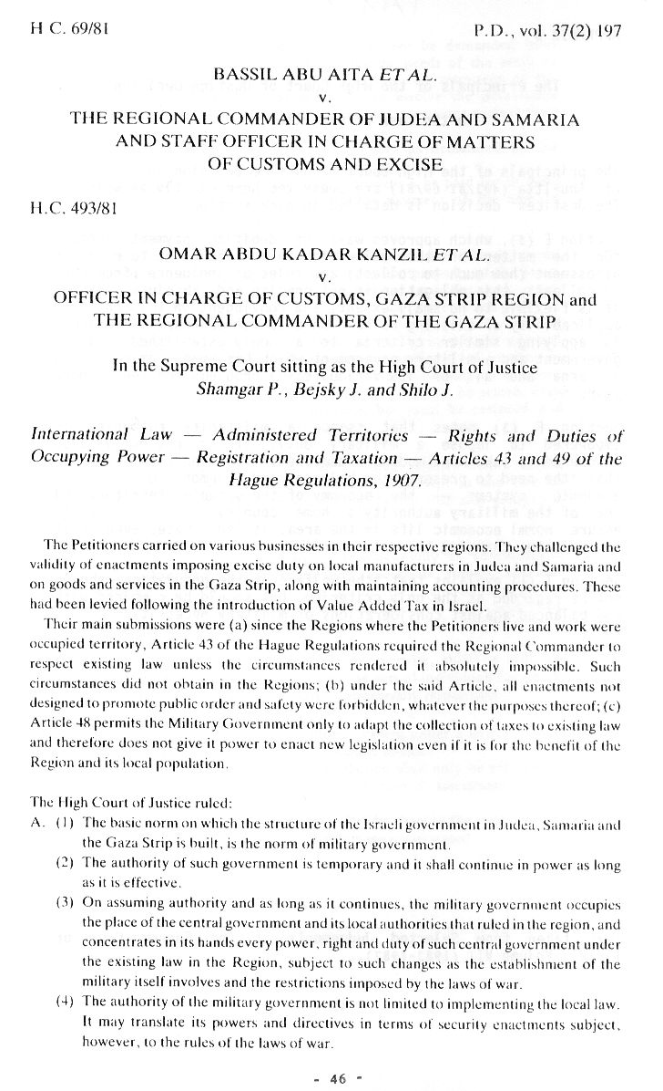
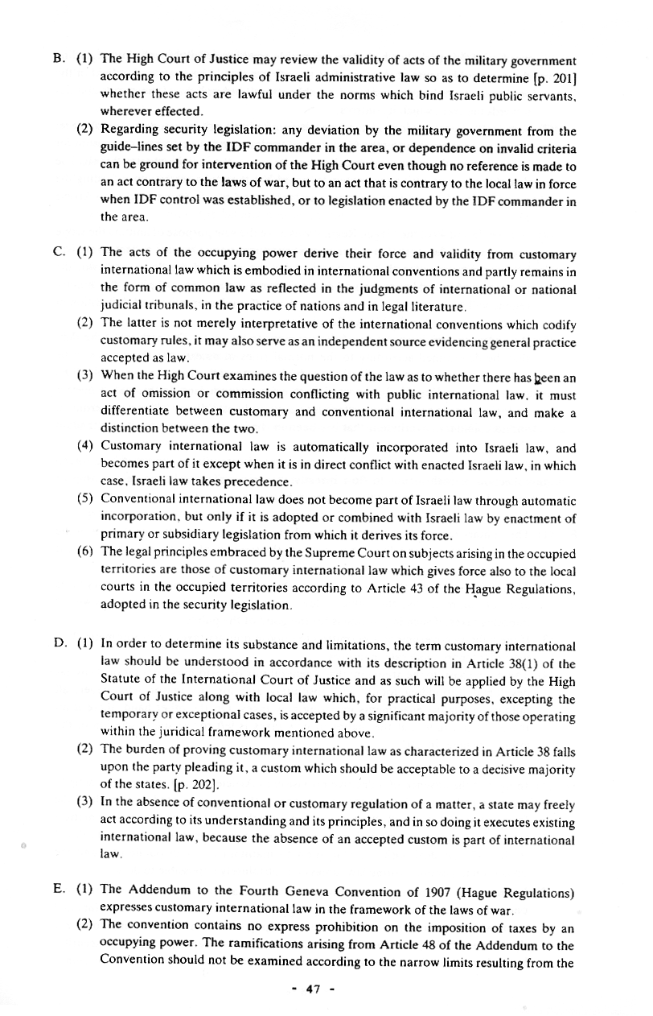
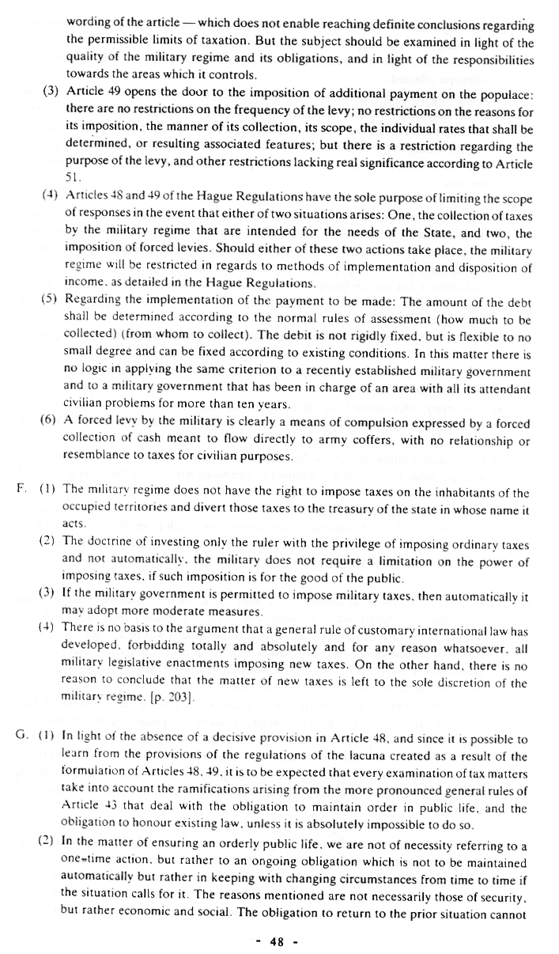
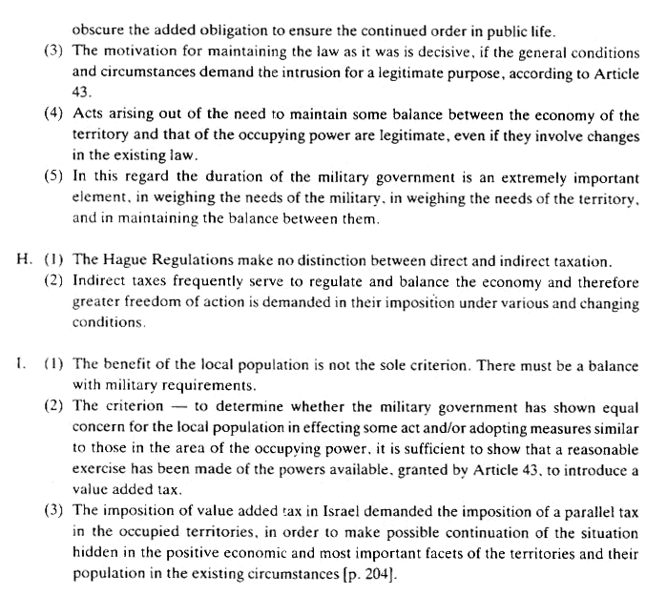
APPENDIX C: Ruling in the Margins by Professor Yoram Dinstein

Value Added Tax in the Occupied Territories
(H.C. 493, 69/81)
Abu Itta et al vs the Regional Commander
of Judea and Samaria

Professor Yoram Dinstein explains the significance of the Abu Itta decision and praises Justice Shamgar for his expertise in international law.

Shamgar's opinion in the case is based on the end of Article 43 of the Hague Regulations, which states that the occupier should respect existing law unless the circumstances render it absolutely impossible.

Dinstein explains that it is difficult to disagree with the factual conclusion that parity must be achieved between the occupied territories and Israel in terms of Value Added Tax. However, the crucial question in his view is whether the requirements of Articles 48 and 49 of the Hague Regulations can be met in light of the condition at the end of Article 43. Dinstein bases his affirmative response on the preeminence of the conditions of Article 43 in the section on the conception of a militant in the Hague Regulations. Since, he says, all the Regulations together comprise a single text, the prohibition on imposing new taxes in Articles 48 and 49 may be understood as the exceptional circumstances referred to in the last phrase of Article 43.

APPENDIX D: Principles of Prof. Gerard Von Glahn's Expert Opinion on the High Court of Justice Ruling on the Abu Itta Case (69/81 493/8)

Professor Gerard Von Glahn, an expert on international law, has criticized the judgement in the VAT case, a case in which he himself gave expert testimony to the Supreme Court.∗ In his article, Von Glahn makes clear that international law (especially Article 43 of the Hague Conventions) prohibits imposition of new taxes on residents of occupied territory unless imposed for the benefit of those residents. In his opinion the Supreme court was not presented with sufficient proof that VAT was imposed for the benefit of the territories' population. He feels that the Court's conclusion that taxes are "a vital means encompassing a complete range of positive economic phenomena which are of extreme importance to the population in the given situation" (in the words of Justice Shamgar) is neither sufficiently grounded in fact, nor justified by the arguments which the court has heard.

APPENDIX E: List of Orders Concerning Income Tax, Assessments and Collection (Judea and Samaria)

A. Order Amending the 1964 Law

1. In Numbered Series

("RED" refers to orders dealing with Rates, Exemptions, or Deductions, or all three together)

- (Amendment 1 was not published as a numbered amendment to the 1964 law, but as the Order Concerning Amendment of the Income Tax Law (No. 543), 1974).

- Order Concerning
Amendment of the
Income Tax Law,
l4
" (Amendment 2), 1976, No. 655 (RED)
" (Amendment 3), 1977, No. 725 (RED)
" (Amendment 4), 1978, No. 754 (RED)
" (Amendment 5), 1978, No. 770 (Fines, Advance
Payment)
" (Amendment 6), 1979, No. 782 (RED)
" (Amendment 7), 1979, No. 791 (Fines)
" (Amendment 8), 1980, No. 816 (RED)
" (Amendment 9), 1980, No. 835 (RED)
" (Amendment 10), 1980, No. 773 (RED)
" (Amendment 11), 1981, No. 900 (RED)
" (Amendment 12), 1981, No. 907 (RED)
" (Amendment 13), 1981, No. 920 (RED)
" (Amendment 14), 1981, No. 924 (Extending
Payment Period)
" (Amendment 15), 1981, No. 943 (RED)
" (Amendment 16), 1982, No. 958 (RED)
" (Amendment 17), 1982, No. 976 (RED)
" (Amendment 18), 1982, No. 978 (RED)
" (Amendment 19), 1982, No. 1014 (RED)
" (Amendment 20), 1982, No. 1020 (RED)
" )Amendment 21), 1983, No. 1050 (RED)
" (Amendment 22), 1983, No. 1062 (RED)
" (Amendment 23), 1983, No. 1084 (RED)
" (Amendment 24), 1983, No. 1094 (RED)
" (Amendment 25), 1984, No. 1098 (RED)
" (Amendment 26), 1984, No. 1106 (RED)
" (Amendment 27), 198?, No. 1143 ( )
" (Amendment 28), 1985, No. 1160 ( )
" (Amendment 29), 1986, No. 1174 (Objection
Procedures)
" (Amendment 30), 1986, No. 1176 (Returned
Payments)
" (Amendment 31), 1987, No. 1185 (Authority to
Amend Special
Regulations)
" (Amendment 32), 1987, No. 1206 (Presentation
in Objections
Committee)
" (Amendment 33), 1987, No. 1225 (RED)
" (Amendment 34), 1988, No. 1241 (Enforcement of
Payment)
" (Amendment 35), 1988, No. 1247 (Accounting
Laws)
" (Amendment 36), 1989, No. 1266 (Definitions of
Differences in
Value)

2. In Non-numbered Series

- Order Concerning Income Tax Appeals, 1967, No. 109
- Order Concerning Income Tax Appeals, 1967, No. 406
- Order Concerning Amendment of Income Tax Law, 1972, No. 485(RED)
- Order Concerning Payment of Taxes, 1973, No. 509 (Payment in New Israeli Sheqels and Not Jordanian Dinars)
- Order Concerning Income Tax Law, 1974, No. 53 (Authority to Exempt from Tax, Cost of Living Increase)
- Order Concerning Payment of Taxes, (Temporary Instructions, 1975, No. 586
- Order Concerning Payment of Taxes, (Temporary Instructions, 1975, No. 612
- Order Concerning Amendment to Income Tax Law, 1976, No. 636 (RED)

3. Orders Affecting Both Income Tax and Property Tax

- Order Concerning Income Tax and Property Tax, 1967, No. 28 (Orders)
- Order Concerning Income Tax and Property Tax, 1967, No. 28 (Orders)
- Order Concerning Income Tax and Property Tax, 1967, No. 84 (Orders) (Amendment 1)
- Order Concerning Income Tax and Property Tax, 1967, No. 120(Orders) (Amendment 1)
- Order Concerning Income Tax and Property Tax, 1967, No. 28 (Orders)
- Order Concerning Income Tax and Property Tax, 1967, No. 238 (Orders) (Brackets)

4. Regulations Approved by Military Orders

A. Approved by Order 28:

- Income Tax Regulations, (Deduction from Insurance Premiums) 3/86
- Income Tax Regulations, (Establishment of Payments for Construction Work and Transport Work as Income), 4/86
- Income Tax Regulations, (Deduction of Insurance Premiums), 5/86
- Income Tax Regulations, (Deduction of Payments for Construction Work and Transport Work), 6/86
- Delegation of Authority No. 49, 7/86
- Income Tax Regulations, (Withholding Method), 1/87
- Income Tax Regulations, (Several Amendments Relating to Assesment Year)
- Income Tax Regulations, (Establishment of Payments for Construction Work and Transport Work as Income) (Amendment), December 2, 1989

B. Approved by Order 111:

- Order Relating to Erratum in Amendment

B. Orders Amending Collection of Capital Transactions of the Government 1952

- Order Concerning Amendment to Collection of Government Monies Law, 1967, No. 113 (Transfer of Authority to Military Commander of the West Bank)
- Order Concerning Amendment to Collection of Government Monies Law, 1967, No. 135 (Amendment 1) (Granting Power to Representing Authority)
- Order Concerning Structure of Power and Authority, April 10,1973, no number
- Order Concerning Amendment to Collection of Government Monies Law, 1983, No. 1095 (Amendment 2) (Permission for Attachment of Third Party Property)
- Order Concerning Amendment to Collection of Government Monies Law, 1987, No. 1193 (Amendment 3) (Power to Declare any Payment Subject to 1952 Law)
- Definitions Concerning Collection of Government Monies, approved by Order 113.

C. Miscellaneous

- Order Concerning Collection of Capital (Lenient Authority) (Temporary Instructions) 1988, No. 1262 (Issue of License Dependent on Payment of Taxes)
- Order Concerning Administrative Violations
(No. 1263), 1988.

List of Orders and Regulations Concerning Value Added Tax

A. Orders and Regulations Amending Jordanian Law Concerning Excise on Local Products, 1963, No. 16.

1. Amendments 1-6 (1967-1988, inclusive)
2. Regulations Concerning Excise on Local Products, April 26, 1985 3. Regulations Concerning Keeping Balance Books, April 26, 1985

B. Amendments Approved Following 1963 Law on Local Products and Amendments Relating to Excise on Local Products, April 26, 1985:

1. Amendments Relating to Excise on
Local Products, Amendment No. 7, September 7, 1986
2. " " 8, November 30, 1986
3. " " 9, March 16, 1986
4. " " 9, August 18, 1987
5. " " 10, April 8, 1987
6. " " 11, May 10, 1987
7. " " 12, July 1, 1987
8. " " 13, September 1, 1987
9. " " 14, November 20, 1987
10. " " 15, December 13, 1987
11. " " 16, September 6, 1988
12. " " 17, October 23, 1989
13. " " 18, February 1, 1989
14. " " 19, February 2, 1989
15. " Declaration Relating to Excise on Local Products (Role of Egypt as a Neighboring State), May 7, 1987.

APPENDIX F: Letter from B'Tselem to taxation staff officer, and response

B'Tselem - The Israeli Information Center for Human
Rights in the Occupied Territories

26.10.89
Ref. 231

To:
Mr. Shimon Mizrahi
Staff Officer/Taxes
P.O.B. 36
Beit El

Dear Sir,

B'Tselem is preparing a report entitled The Use of the Taxation System in the West Bank and Gaza Strip as an Instrument for Enforcing the Law During the Uprising.

In the course of our work on the report, we found that we were missing certain figures which are listed below.

I would be grateful if you could assist us in obtaining this information so that the report can be thorough, comprehensive, and credible.

1. A list of the orders and amendments promulgated by the Civil Administration since 1967 regarding tax collection in the territories.
2. The dates on which these orders were issued.
3. A list of the fees and permits which a resident of the territories can only receive from the Civil Administration.
4. A description of the methods of tax collection prior to the Intifada and thereafter have these changed at all?

Sincerely,
( - )
Zahava Gal'on
Executive Director
B'Tselem
Civil Administration for the Judea and Samaria Region
Staff Officer/Taxes
Beit El P.O.B. 36 Tel. 976438

Our reference: 2-01/820
Date: October 31, 1989

Executive Director, B'Tselem
8 Hatibonim St., Jerusalem

Re: Figures

I regret that I am unauthorized to supply the figures requested in your letter.

Sincerely ( - ) Chaim Hova Deputy Staff Officer/Taxes

APPENDIX G: Letters from B'Tselem to Legal Advisor for the Judea and Samaria Region, and Response

B'Tselem - The Israeli Information Center for Human
Rights in the Occupied Territories

December 12, 1989

To:
Colonel Ahaz Ben-Ari
P.O.B. 10482
Beit El

Dear Sir,

In preparing a report on the subject of taxation in the territories, we encountered a number of questions concerning legislation.

I would be grateful if you could help us clarify two issues:

1. Except for Order 1262, is there an order which makes
the granting of a service or a license contingent on payment of taxes?

2. Is there justification for the refusing to issue a birth certificate because taxes have not been paid?

Your answers will help us better understand this complicated subject.

Thank you in advance.

Sincerely,

Dr. Daphna Golan

B'Tselem - The Israeli Information Center for Human
Rights in the Occupied Territories

December 27th,1989

To:
Colonel Ahaz Ben-Ari,
P.O.B. 10482
Beit El

Dear Sir,

Enclosed please find a report on the military judicial system in the territories. I hope you find it of interest.

I hope you can help us prepare our report on taxation in the territories (re.: my letter of December 12, 1989), especially with regards to clarifying the issue of orders other than Order No.1262 which deal with taxation in the territories.

Thank you in advance and happy holidays.

Sincerely,

Dr. Daphna Golan

I S R A E L D E F E N C E F O R C E S
JUDEA AND SAMARIA REGION
OFFICE OF THE LEGAL ADVISOR

Date: January 23, 1990
Ref: 164/00 -- 12438
To:
B'Tselem -- Dr. Daphna Golan
8 Hatibonim St.
Jerusalem
Dear Madam,

RE: Order Concerning Collection of Taxes (Auxiliary Authorities)(Temporary Instructions) (No. 1262) (Judea and Samaria), 1988
Your letter: Ref. 287 of December 12, 1989

1. The above order is a general order which sets out cases in which a "non-liability" form can be demanded of a resident, or in which provision of a service or license can be made contingent on presentation of such a form.

2. In addition to this order, there are specific instructions in other laws according to which registration or provision of service can be withheld pending settlement of debt. Two examples:

a. Article 14 of the Public Monies Collection Law (parallel to Article 11a of the Taxes (Collection) Order in Israel) permits delaying the registration of lands until the debtor settles all debts relating to such lands.

b. Article 172b of the Order Concerning Transport Laws (Traffic Provisions) (Judea and Samaria) (No. 399),1970 states that the Licensing Authority can refuse to grant or renew a driving license until the person requesting the license proves, to the satisfaction of the former, that every fine legally imposed on him for a traffic violation or other violation resulting from driving a vehicle has been paid.

Sincerely,
( - )
Ahaz Ben Ari, Colonel
Legal Advisor
ABA/pn
---------------------------------------------------------
P.O.B. 10482, BEIT EL. TEL: 02-249989, 213251

APPENDIX H: Data on Principle Tax Laws in the Territories

THE STATE OF ISRAEL
MINISTRY OF DEFENSE

Office of The Coordinator of Activities in
Judea, Samaria and the Gaza Strip

A. General: Following is a list of the principles of the Law of Taxation which were valid in the Judea and Samaria Region and Gaza Strip Regions before 1967, and are still valid, subject to the amendments made in Security Legislation:

1. In the Judea and Samaria Region:
a. The Law of Income Tax, No. 25, 1964.
b. The Law of Land Tax, No. 30, 1955 (Property
Law, both agricultural and rural)
c. The Law of Buildings and Land Tax within the municipal areas, No. 11, 1954 (Urban Property Tax Law(
d. Clause 41(c) to the Law of Municipalities, No. 29, 1955(authorizing municipal councils to issue regulations concerning the collection of taxes with regards to the other authorities granted to the council)
e. Education Tax Regulations, No. 1, 1956.

2. In the Gaza Strip Region:

a. Income Tax Order, No. 13, 1947.

b. Agricultural Property Tax Order, No. 5, 1942.

c. Urban Property Tax Order, No. 24, 1942.

d. Article 102 in the Municipalities Order, No. 1, 1934(authorizing a municipal council to impose municipal rates).

B. Income Tax and Property Tax:

1. Income Tax:

a. Individual Income Tax brackets in the Judea and Samaria and Gaza Strip Regions are as follows:

Monthly Bracket
Cumulative: Cumulative: Total:
122.2 1,600 1,600 ??
266.6 3,200 1,600 7.7%
400.0 4,800 1,600 11.0%
511.0 6,132 1,332 16.5%
622.0 7,464 1,332 22.0%
733.0 8,796 1,332 27.5%
944.0 10,128 1,332 33.0%
1,177.0 14,124 3,996 38.5%
1,732.0 20,784 6,660 44.0%
2,287.0 27,444 6,660 49.0%
Every added Sheqel 55.0%

b. Variance from Income Tax in Israel:

1. Income from agriculture in the Judea and Samaria Region is tax-exempt (farmer's direct income; income from agricultural trade is taxed(.
2. Residents of the Judea and Samaria and Gaza Strip Regions employed in Israel are exempt from income tax in their region because they pay income tax in Israel (preventing duplicate taxation).

3. In the Judea and Samaria and Gaza Strip Regions there is no Capital Gains Tax.

c. Company Profit Tax is at a uniform rate of 38.5% in the Judea and Samaria Region and 37.5% in the Gaza Strip Region, compared to over 40% in Israel.

2. Property Tax, the Judea and Samaria Region:

a. Rural Property Tax

1. Applies to irrigated land only.

2. The tax is calculated according to the crop
type and the land area.

3. The tax is a remnant of the Property Tax imposed by Jordanian authorities (the tax applied to both irrigated and non-irrigated land until 1963 when the tax on non-irrigated land was abolished).

b. Urban Property Tax

1. Buildings

a. The tax is 17% of a building's annual rental value.

b. The annual rental value is determined by an assessment board as follows:

1. Original assessment
2. Option for enclosure
3. Final assessment
A new evaluation is made every 3-6
years depending on circumstances.

2. Vacant Land

a. The tax equals six mils of the land value.
b. The land value is determined by the assessment
board as described above.

3. Property Tax is collected by the Civil Administration. 90% of the revenue is transferred to the municipalities (90% of the income in every city is transferred to the municipal treasury) and 10% remains in the Civil Administration treasury to finance collection expenses.

3. Business Tax

a. The Judea and Samaria Region

1. Annual fee for every business license subject to the Business Tax Law, No. 89, 1966 (Jordanian Law)

2. Collection conducted by the Civil
Administration -90%is transferred to the municipality and 10% remains in the Civil Administration Treasury (similar to Property Tax)

3. Tax grading - according to type of business.

b. The Gaza Strip Region - Business Tax collected by municipal authorities.

c. Customs duties, Excise and Excise Added Tax - The Staff Officers in charge of customs in the Judea and Samaria Region and Gaza Strip Regions collect the following taxes:

1. Customs duties - the same regulations that apply to Israel apply to these regions.

2. Excise Added Tax - parallel to Israeli Value Added Tax.

3. Excise - Purchase Tax applying to a list of specific goods such as: cigarettes, plastic products, batteries.

4. Stamp duty - applications made to the Civil Administration, contracts, and exit permits for the Jordan bridges must be have income stamps affixed to them.

d. Fees

1. A fee, in principle, is not mandatory but rather a payment for a particular service (like issuing a license). In general, one can say that the residents of the Judea and Samaria and Gaza Strip Regions are required to pay fees for services similar to those which require fees in Israel.

2. The principal fees collected in the Judea and Samaria and Gaza Strip Regions are fees for business licensing, health insurance fees, transit fees for crossing the Jordan bridges and the Rafah terminal and fees for the issue of licenses (such as driving license).

e. Vehicle fee

1. As of July 1988 (in the Gaza Strip Region) and September 1988 (in the Judea and Samaria Region) a vehicle fee has been imposed on vehicle owners in the Judea and Samaria and the Gaza Strip Regions.

2. The fees are calculated according to type of vehicle (private car, truck, bus, etc.), motor volume, and model year.

3. The fees are similar to those charged in Israel in1985, subject to adjustment for (according to the Consumer Price Index) and model year updating.

f. Non-Liability: Following is a list of documents, licenses, and services contingent on production of a Non-Liability Form ("Travel Form", as defined by MK Oron).

1. The Judea and Samaria Region

a. Personal Exit Permit - for leaving the area
b. License subject to the Press and Advertising
Law valid in the area
c. Business License
d. Application Clerks License
e. Licensed Auditor's License
f. Certified Surveyor's License
g. Insurance Agent and Insurer's License
h. Mining and Quarrying License
i. Construction License (Planning and Construction
License)
j. Antique Dealer's License
k. Tourism Operator's License
l. Granting a license under the telephone
regulations valid in the area
m. Permit to set up a plant
n. Vehicle License
o. Driver's License
p. Transfer of Vehicle Ownership Registration
q. Special Permit to bring in funds
r. Providing a Service under the Companies Law
valid in the area
s. Providing a Service under the Law of Trade
Names Registration valid in the area
t. Providing a Service under the Law of Trademarks
valid in the area
u. Permit to Transport Goods into and out of the
region
v. Personal Permit to transfer and hold foreign
currency
w. Issuing Vehicle License Plates.

2. The Gaza Strip Region

a. Permit to Transport Goods into and out of the
region
b. Commercial Vehicle License
c. Commercial Vehicle Driver's License
d. Transfer of Vehicle Ownership Registration
e. Business Licensing
f. Vessels Licensing
g. Fishing License
h. Special Personal Permit to bring in funds
i. Special Personal License for transferring and
holding foreign currency
j. Insurance Agent and Insurer's License
k. Service under the Companies Order valid in the
region
l. Service under the Trade Marks Order valid in
the region
m. Service under the Law of Business Registration
valid in the region
n. Construction License
o. Land Transactions Registration
p. Mining License
q. Granting License to open garages and vehicle
factories
r. Providing Service under the Law Concerning
Settling the Affairs of Companies, Offices, and
Travel and Tourism Agencies
License or Service under the Surveying Order
valid in the region

APPENDIX J: Collection Data – Judea and Samaria Region Tax Years 1986, 1987, 1988

In New Israeli Sheqels and in percentages
Period | 86 | 87 | 88 | Growth Rate
Tax | April 86 through March 87 | April 87 through March 88 | April 88 through March 89 | Normal |  | Real
 |  |  |  | 1987 vs 1986 | 1988 vs 1987 | 1987 vs 1986 | 1988 vs 1987
Total Taxes and Debt Payments | 138,607 | 158,820 | 149,729 | 14.6 | -5.7 | -2.9 | -19.7
Income Tax | 37,126 | 50,631 | 47,514 | 36.4 | -6.2 | 15.6 | -20.1
Property Tax | 6,220 | 6,375 | 6,471 | 2.5 | 1.5 | -13.1 | -13.6
Employers' tax | 1,519 | 1,727 | 1,608 | 13.7 | -6.9 | -3.6 | -20.7
Rural Property Tax | 358 | 282 | 169 | -21.2 | -40.1 | -33.2 | -49.0
Total Direct Taxes | 45,223 | 59,015 | 55,762 | 30.5 | -5.5 | 10.6 | -19.5
Customs Duties | 6,117 | 4,585 | 5,495 | -25.0 | 19.9 | -36.5 | 2.1
Excise | 27,137 | 28,063 | 26,459 | 3.4 | -5.7 | -12.3 | -19.7
Stamp Tax (incl.  sales by Postal  Authority) | 22,155 | 22,263 | 22,401 | 0.5 | 0.6 | -14.8 | -14.3
Excise Added  Tax (EAT) | 42,433 | 47,895 | 43,722 | 12.9 | -8.7 | -4.3 | -22.3
Levies and  Bridge Tolls | 1,082 | 1,464 | 1,028 | 35.3 | -29.8 | 14.7 | -40.2
Total Gross  Indirect Taxes | 98,924 | 104,270 | 99,105 | 5.4 | -5.0 | -10.6 | -19.1
Rebates | 5,540 | 4,465 | 5,138 | -19.4 | 15.1 | -31.7 | -2.0
Total Net Indirect Taxes | 93,384 | 99,805 | 93,967 | 6.9 | -5.9 | -9.4 | -19.8
Compiled by: L. Bartov

Collection Data – Gaza Strip Region
Tax Years 1986, 1987, 1988

In New Israeli Sheqels and in percentages
Period | 86 | 87 | 88 | Growth Rate
Tax | April 86 through March 87 | April 87 through March 88 | April 88 through March 89 | Normal |  | Real
 |  |  |  | 1987 vs 1986 | 1988 vs 1987 | 1987 vs 1986 | 1988 vs 1987
Total Taxes and Debt Payments | 35,642 | 39,337 | 48,495 | 10.4 | 23.3 | -6.4 | 5.0
Income Tax | 20,172 | 20,114 | 27,570 | 0.3 | 37.1 | -15.5 | 15.4
Urban Property Tax | 293 | 249 | -- | -15.0 | -- | -27.9 | --
Rural Property Tax | 170 | 135 | -- | -20.6 | -- | -32.7 | --
Total Direct Taxes | 20,635 | 20,498 | 27,570 | -0.7 | 34.5 | -15.8 | 14.5
Customs Duties | 1,250 | 1,060 | 1,357 | -15.2 | 28.0 | -28.1 | 9.0
Excise | 436 | 462 | 239 | 6.0 | -48.3 | -10.2 | -55.9
Stamp Tax | 873 | 581 | 1,590 | -33.5 | 173.7 | -43.9 | 133.1
Excise Added Tax (EAT) | 13.928 | 16.736 | 19,076 | 20.2 | 8.0 | 1.9 | -8.0
Total Gross Indirect Taxes | 16,487 | 18,839 | 21,262 | 14.3 | 12.9 | -3.1 | -3.9
Rebates | 1,480 | -- | 337 | -- | -- | -- | --
Total Net Indirect Taxes | 15,007 | 18,839 | 20,925 | 25.5 | 11.1 | 6.4 | -5.4
Compiled by: L. Bartov

Collection Data – Judea and Samaria Region
April-March 1985/86 and 1986/87

In New Israeli Sheqels and in percentages
Period  Tax | March |  | April-March |  | Growth Rate
Period  Tax | 1986 | 1987 | 1985/86 | 1986/87 | Normal |  | Real
 |  |  |  |  | Mar | Ap-Mar | Mar | Ap-Mar
Total Taxes and Debt Payments | 10,298 | 13,189 | 102,786 | 138,607 | 28.1 | 34.9 | 4.1 | 3.6
Income Tax | 2,890 | 3,920 | 26,295 | 37,749 | 35.6 | 41.2 | 10.3 | 8.4
Property Tax | 1,455 | 729 | 4,194 | 6,220 | -49.9 | 48.3 | -61.6 | 13.9
Employers' tax | 23 | 22 | 931 | 1,519 | -4.4 | 63.2 | -22.2 | 25.3
Rural Property Tax | 134 | 100 | 329 | 358 | -25.4 | 8.8 | -39.3 | -16.4
Total Direct Taxes | 4,502 | 4,771 | 31,749 | 45,223 | 6.0 | 42.4 | -13.8 | 9.4
Customs Duties | 462 | 290 | 4,103 | 6,117 | -37.2 | 49.1 | -49.0 | 15.5
Excise | 1,843 | 1,933 | 18,658 | 27,137 | 4.9 | 45.4 | -14.7 | 11.7
Stamp Tax(incl.  sales by Postal  Authority) | 1,398 | 2,767 | 26,776 | 22,155 | 97.9 | -17.3 | 60.9 | -36.5
Excise Added  Tax (EAT) | 2,536 | 3,696 | 25,309 | 42,433 | 45.7 | 67.7 | 18.5 | 28.8
Levies and Bridge Tolls | 121 | 102 | 626 | 1,082 | -15.7 | 72.8 | -31.5 | 32.8
Total Gross  Indirect Taxes | 6,360 | 8,788 | 75,472 | 98,924 | 38.2 | 31.1 | 12.3 | 0.7
Total Rebates | 564 | 370 | 4,435 | 5,540 | -34.4 | 24.9 | -46.7 | -4.1
Total Net Indirect Taxes | 5,796 | 8,418 | 71,037 | 93,384 | 45.2 | 31.5 | 18.1 | 1.0
Compiled by: L. Bartov

Collection Data – Gaza Strip Region
April-March 1985/86 and 1986/87

In New Israeli Sheqels and in percentages
Period  Tax | March |  | April-March |  | Growth Rate
Period  Tax | 1986 | 1987 | 1985/86 | 1986/87 | Normal |  | Real
 |  |  |  |  | Mar | Ap-Mar | Mar | Ap-Mar
Total Taxes and Debt Payments | 1,935 | 5,240 | 19,256 | 35,642 | 170.8 | 86.1 | 120.2 | 42.2
Income Tax | 1,125 | 2,896 | 10,960 | 20,172 | 157.4 | 84.1 | 109.3 | 41.4
Urban Property Tax | 15 | 30 | 245 | 293 | 100.0 | 19.6 | 62.6 | -8.2
Rural Property Tax | 8 | 17 | 101 | 170 | 112.5 | 68.3 | 72.7 | 29.3
Total Direct Taxes | 1,148 | 2,943 | 11,306 | 20,635 | 156.4 | 82.5 | 108.4 | 40.2
Customs Duties | 9 | 951 | 220 | 1,250 | 10,466.7 | 468.2 | 8490.8 | 336.4
Excise | 31 | 44 | 293 | 436 | 41.9 | 48.8 | 15.4 | 14.3
Stamp Tax | 27 | 39 | 480 | 873 | 44.4 | 81.9 | 17.4 | 39.7
Excise Added  Tax (EAT) | 723 | 1,422 | 7,821 | 13,928 | 96.7 | 78.1 | 59.9 | 36.8
Total Gross  Indirect Taxes | 790 | 2,456 | 8,814 | 16,487 | 210.9 | 87.1 | 152.8 | 43.7
Rebates | 3 | 159 | 864 | 1,480 | 5200.0 | 71.3 | 4,208.9 | 31.6
Total Net Indirect Taxes | 787 | 2,297 | 7,950 | 15,007 | 191.9 | 88.8 | 137.3 | 45.0
Compiled by: L. Bartov

APPENDIX K: Order No. 1262

ISRAEL DEFENCE FORCES

MANIFESTOS, ORDERS, AND APPOINTMENTS
FOR JUDEA AND SAMARIA
Title: Order Concerning Tax Collection (Auxiliary Authorities) (Temporary Instructions) (No. 1262) (Judea and Samaria), 1988.

Reg. No.: Order No. 1262

Distribution: Orders

---------------------------------------------------------------------

ISRAEL DEFENCE FORCES
Order No. 1262

Order Concerning Tax Collection (auxiliary Authorities)
(Temporary Instructions)

By the powers vested in me as Commander of Regional IDF forces, and being of the opinion that due to the special circumstances prevailing in the area, doing so is necessary in order to maintain public order and local security, I hereby order the following:

Definitions

1. In this order -

"Controller" -
(1) In a partnership, a partner;
(2) In a corporation, anyone entitled to purchase or in possession of one of the following:
(a) At least 25% of the shares issued;
(b) The right to receive at least 25% of the corporation's
profits or surplus assets if it is dismantled, after payment of debts;
(3) In a non-corporate body of people, the person who has actual control of the company;

"Tax" - Tax, fee, fine or other compulsory payment, as listed in the first appendix of this order, all or part thereof, including differences resulting from indexing, interest, and fines and other payments imposed in connection with these, and including any advance payment or sums withheld at source as tax from payment to another person;

"Tax Law" - Law or security legislation according to which a tax is imposed.

"License" - Permit or license for performing an act or activity, granted by the Commander of Regional IDF forces or one of his authorities, under the law or security legislation;

"Tax authority" - Authority responsible for implementation of the tax law;

"Service" - Service given to the public by the Commander of Regional IDF forces or one of his authorities, under the law or security legislation.

Making Issue of a License or Service Contingent on Production of Evidence

2. (a) A person authorized to issue a license or a service in
accordance with the instructions of the law or security legislation listed in the second appendix of this order, is authorized to make provision of that service or license, or its renewal, contingent on production of evidence which, in the opinion of the authorized person mentioned, indicates that the applicant has done everything required of him by all tax laws, and has paid tax he owes at that date (hereafter: "satisfactory evidence").

(b) If, before presenting the application for a license or its
renewal or a service, a person applying for a license or a service submits an objection or a legal appeal of his obligation to pay a tax, or of the rate or sum of the tax, and in the absence of any contradictory instruction in the tax law, the disputed tax shall not be considered a tax which the applicant owes at that time.

(c) The tax authority shall issue the applicant a permit stating that the instruction of (a) above applies to him, in order to fulfill the demand for presentation of satisfactory evidence in accordance with (a) above, within 10 days of the day on which the application for the issue of such a permit was received.

(d) If the tax authority refuses to issue the applicant with a permit as stated in (c) above, or fails to issue it within the period specified therein, the applicant is entitled to appeal to a review board established under the Order Concerning Review Boards¯(Judea and Samaria) (No. 172), 1967.

(e) A permit issued by the tax authority to serve as satisfactory evidence in accordance with (a) above shall not be considered evidence of the correctness of its contents or of a person's fulfillment of duties under any tax law, except for the purposes of (a) above, and such a permit shall not oblige the tax authority when it comes to determining the obligations of the person receiving the permit.

Controllers

3. (a) If the applicant for a license or a service is the controller of a corporate or non-corporate company of people (hereafter "company"), the person authorized to issue the license or service is entitled to make them contingent on production of satisfactory evidence on the part of the company.

(b) If the applicant for a license or a service is a company, the person authorized to issue a license or service is entitled to make them contingent on production of satisfactory evidence on the part of the controller of the company.

(c) The instructions of item 2 shall apply, with the necessary amendments, to the stipulations stated in (a) and (b) above.

Regulations

4. The head of the Civil Administration is entitled to specify, in regulations, instructions for the implementation of this order.

Amendment of Appendices

5. The head of the Civil Administration is entitled, in regulations, to amend the contents of the appendices to this order.

Validity

6. This order shall become valid on the day on which it is signed and shall remain valid for six months from the day on which it becomes valid.

Retroactivity

7. Any action taken in accordance with this order before it becomes valid shall be considered as having been done under the instructions of this order.

Title

8. This order shall be entitled: "Order Concerning Tax collection (Auxiliary Authorities) (Temporary Instructions) (Judea and Samaria) (No. 1262), 1988.

First Appendix

1. Income tax and property tax as defined in the Order Concerning Income Tax and Property Tax (Judea and Samaria) (No. 24), 1967;

2. Customs tax and added customs tax, as defined in the Regulations Concerning Customs Tax on Local Goods (Judea and Samaria), 1985;

3. Special levy in accordance with the Order Concerning Special Levies (Vehicles) (Temporary Instructions) (Judea and Samaria) (No. 1249), 1988;

4. A fine imposed in accordance with the law or security legislation.

Second Appendix

1. Personal permit to leave the area under clause 90 of the Order Concerning Security Instructions.

2. Press and Advertising Law No. 16, 1967;

3. Labor and Licenses Law No. 89, 1966;

4. Trade and Industry Law No. 16, 1953;

5. Registration of Applicants Law No. 42, 1966;

6. Professional Employment Law, Accountancy, No. 10, 1961;

7. Licensed Surveyors' Licensing Law No.7, 1948;

8. Inspection of Insurance Business Law No. 5, 1965;

9. Order Concerning Prohibition of Employment (Judea and Samaria) (No. 65), 1967;

10. License for Mining and Quarrying in Accordance with the Regulation of Natural Resources Law No. 37, 1966;

11. Town, Village and Buildings Planning Law NO. 79, 1966;

12. Antiquities Law No. 51, 1966;

13. Tourism Law No. 45, 1965;

14. Telephone Regulations No. 1, 1951;

15. Instructions Concerning Establishment and Inspection of Factories No. 1, 1966;

16. Vehicle license, driver's license and registration of vehicle owners' offences in accordance with the Transport Law (Traffic Regulations) (Judea and Samaria) (No. 399), 1970;

17. Personal permit in accordance with the Order Concerning Bringing Money into the Area (Judea and Samaria) (No.¯973), 1981;

18. Membership Law No. 12, 1964;

19. Registration of Trade Names Law No.30, 1953;

20. Trade Symbols Law No. 33, 1952;

21. Order Concerning Transferal of Goods Judea and Samaria) (No. 1252), 1988;

22. Personal permit in accordance with the Order Concerning Currency Control (Judea and Samaria) (No. 952), 1981;

23. Issuing of vehicle license plates in accordance with the Fourth Appendix of the Transport Law NO. 49, 1958.

December 17, 1988
( - )
------------------------------
Brigadier General Amram Mitzna
Commander of IDF Forces
Judea and Samaria Region

APPENDIX L: Petition of the Association for Civil Rights in Israel on Confiscation of Identification Cards

THE SUPREME COURT SITTING AT THE HIGH COURT OF JUSTICE

H.Ct.J.:278/89
Before:
The Honorable Chief Justice M. Shamgar
The Honorable Justice M. Bejsky
The Honorable Justice A. Matza

The Petitioners:

1. Zien Yiheye Yusuf Khalil
2. Abd Juad Hamed Arab Abdu
3. Mussa Muhamed Salem Kharizat
4. Hussnie Muhamed Said Ahmed
5. Jamal Mahmud Razi Jerar
6. Fahmie Khazem Muhamed Hassan Rajabi
7. Hanieh Yusuf Jaber
8. The Association for Civil Rights in Israel

Versus:

The Respondents:

1. Commander of IDF Forces in the
Judea and Samaria Region.
2. Head of the Civil Administration of the
Judea and Samaria Region.

Plea for the issue of order nisi

Date: June 26, 1989

For the Petitioners: Adv. Joshua Schoffman, Adv. Dan Simon
For the Respondents: Adv. Menachem Mazoz.

Judgement:

The Chief of Justice:

In this plea, the petitioners present their criticism of the procedure, frequently used in the Judea and Samaria Region, of confiscating the ID cards of a resident when attempting to coerce him to perform an action required from him by the authorities, including payment of debts and tax. The card is returned only after the requirement has been met.

During the first hearing the Court held on this case, we were informed by the learned State Attorney, that the respondent is also of the opinion that the confiscation of ID cards should not be permitted unless under circumstances and subject to conditions clearly defined in Security Legislation. Lacking such instructions, it is not permissible to confiscate documents. To clarify said legal situation, we have been asked to postpone the hearing to a later date to allow the issue of an order which will clarify the distinction between the permissible and the prohibited.

According to a communique we received from the State Attorney's Office on June 23, 1989, an Order Concerning Security Instructions, (Amendment No. 59) (Judea and Samaria) (No. 1276), 1989 was issued on May 24, 1989. This order settles the issue of the confiscation of ID cards. A similar order was issued in the Gaza Strip on May 25, 1989. Supplementary procedures were also provided.

The above communique proceeds to detail the following:

"According to the order, the confiscation of ID cards is permitted in only two types of cases:

(a) For the purpose of ensuring the execution of an instruction, legal by virtue of clauses 88(b) and/or 91a of the Order Concerning Security Instructions (Removal of Roadblocks and Graffiti).

(b) For the purpose of ensuring appearance ordered by any IDF authority, in accordance with clause 73a of the Order Concerning Security Instructions.

The confiscation of ID cards would coincide with the supply of alternative documentation, as detailed in the order. In the case of confiscating an ID card for the purpose of ensuring appearance, the card would be returned immediately following appearance the return of the card would not be contingent on execution of any other action, such as tax payment, etc.

When confiscating an ID card for the purpose of ensuring the execution of an instruction, the card would be returned immediately upon execution of the instruction, or on another date stated on the alternative documentation within the period of its validity".

The honorable Attorney for the petitioners, Adv. Schoffman, informed the court that he does not wish to withdraw his plea at this stage. He has in his possession affidavits from the beginning of June, according to which ID cards were still confiscated in cases where the circumstances did not allow confiscation according to the above amending order. He therefore requested that an order nisi be issued, as stated in the second heading to the plea, that is, an order requiring the respondents to appear before the court and give reason why the respondents and their subordinates should not refrain from confiscating the ID cards of residents of the area.

We did not see fit to issue the requested order. The respondents were aware of the prohibition on confiscating ID cards unless subject to relevant security legislation and executed while following it. An order was issued which included clear instructions prohibiting the confiscation of ID cards in cases similar to those cited by the petitioner (8).

It has also been clearly explained that the procedural regulations issued with the order, include instructions from the Chief of Staff to follow the order and procedures adapted to it, and that the Judge Advocate General issued an instruction to prosecute those who violate the order or the procedure. Under these circumstances, an order, if issued, would not add anything to what has already been done; if anyone violates the order it is possible to file a complaint with the appropriate authorities, amongst others, with the Judge Advocate General's Corps. We gather from the above reply that legal measures will be taken under the Military Law, 1955 against whoever violates the order.

The danger that an individual soldier might violate the order is¯ not sufficient reason to issue the requested order, since under the circumstances an order would add nothing to what the court can already enforce as there is no dispute about the legal situation. Fundamentally, willingness has been expressed to take necessary measures in any concrete case of violation of the order.

It has therefore been decided to reject the plea.

Justice M. Bejsky: I concur.

Justice A. Matza: I concur.

Decided as stated in the opinion of the Chief Justice,
Today, July 6, 1989.

Signed: ( - ) ( - ) ( - )
Presiding, Justice Bejski, Justice Matza.

APPENDIX M: Letter from Adv. Dan Simon to Legal Advisor on Confiscation of Vehicle Licenses

THE ASSOCIATION FOR CIVIL RIGHTS IN ISRAEL
P.O.B. 8273 Jerusalem 91082, Tel: 638385, 667726

July 20, 1989

Colonel Ahaz Ben-Ari,
Legal Advisor
Judea and Samaria Region Civil Administration
P.O.B. 10482 Beit-El

Dear Colonel Ben-Ari,

Re.: The appropriation of vehicle licenses from residents of the Judea and Samaria Region as means of collecting tax

I am writing to you following complains we received about the collection of tax from vehicle owners in the Judea and Samaria Region.

Tax collectors stop cars at roadblocks, set a sum the drivers are required to pay, and as means of ensuring payment - confiscate their vehicle licenses. (For example: this procedure was applied in the case of Hussein Ali Mohsin, ID No. 80107758, on July 5, 1989 in Al-Azariya, and in the case of Ozmat Mustapha Sara, ID No. 959745563 on July 17, 1989 in Tulkarm).

In our opinion, the confiscation of vehicle licenses is an illegal procedure. According to the Order Concerning Collection of Taxes, (Auxiliary Authorities) (Temporary Instruction) No. 1262, tax authorities are authorized to "make provision of a service or a license, including license renewal, contingent on submission of...evidence...", meaning - the law permits the denial of service or license as well as the denial of a license renewal. However, the tax authorities are not authorized to confiscate licenses.

I request that you act to put an immediate end to the confiscation of vehicle licenses as means of collecting tax.

Yours sincerely,

( - )

Dan Simon, Advocate

cc: Brigadier-General S. Erez, Head of the Civil
Administration, Beit-El.
Advocate M. Mazoz, Ministry of Justice, Jerusalem.

APPENDIX N: Letter from the Hotline for Victims of Violence of November 7, 1989, and Response

Hotline for Victims of Violence
2 Abu Obeidah St., Jerusalem
Tel: 02-283555
November 17, 1989

To:
Eli Dayan
Civil Administration
Hebron

Re: The Vehicle of Maher Alhagog

Dear Mr. Dayan,

Pursuant to our telephone conversation, I would like to remind you that Maher Alhagog, who works as a teacher in Yatta, is not the owner of a taxi. His vehicle, for which he was ordered to pay tax, serves solely as a private vehicle.

We would request that you return his permits and treat his case in accordance with the above facts.

Yours sincerely,
( - )
Tsali Goldenberg

[The following was scrawled by hand at the bottom of the original letter:]

To: Tsili Goldenberg 19/11/89
Re: The vehicle of Mahar Alhagog

If you wish to represent the assessee in our office, I would request that you come to our office bearing an appropriate power-of-attorney.
Regarding your question about the vehicle of the person under discussion, a uniform tax has been set for all vehicles since it is known that in the West Bank all vehicles travel and carry passengers for a fee.
I would advise you for the future times when you deal with cases such as this don't come out with declarations and confirmations you noted "facts," because sometimes these things are not correct.

Sincerely,
Eli Yitzhaki

APPENDIX O: Letter from Adv. Dan Simon to Head of Civil Administration on Arbitrary Demands for Tax Payment, Respone of Legal Advisor, and Response of Adv. Simon

THE ASSOCIATION FOR CIVIL RIGHTS IN ISRAEL
P.O.B. 8273 Jerusalem 91082, Tel 638385

July 31, 1989

Brigadier General Shayke Erez
Head of the Civil Administration,
Judea and Samaria Region
P.O.B. 10482, Beit-El

Dear Brigadier General Erez,

Re.: Arbitrary tax payment demands from residents of the Judea
and Samaria Region

I am writing to you following complaints from residents of Judea and Samaria Region who were arbitrarily required to pay various taxes.

Mr. Hussein Ali Muhamed Mohsin, ID No. 80107758, was traveling from Jerusalem to Jericho on July 5, 1989. On that day a tax collection operation took place in Al-Azariya. Mr. Mohsin was summoned by the income tax people who asked him whether he is employed. Mr. Mohsin replied that he is not employed, he is a student (enclosed is a certificate confirming that Mr. Mohsin is a student at the College of Science and Technology in Jerusalem). The tax officials arbitrarily determined that Mr. Mohsin owes the sum of NIS 800. They did this without consulting any lists or books and without making any inquiries to check that debt. Mr. Mohsin also claimed that since he is a resident of Jerusalem he does not belong to the Judea and Samaria Region and they are not authorized to demand any tax payment from him. The tax officials did not pay heed to his claims, they gave him a payment stub for the sum of NIS 800 (copy enclosed) and confiscated his vehicle licenses as means of ensuring payment.

I would like to point out that the confiscation of licenses as means of collecting tax is, in itself, illegal. According to the Order Concerning Collection of Taxes (Auxiliary Authorities) (Temporary Instructions) (No. 1262), tax authorities are empowered to "make provision of a service or a license, including license renewal, contingent on the submission of...evidence...", meaning - the law in the Judea and Samaria Region permits denial of a license as well as denial of license renewal. The authorities are not, however, empowered to confiscate licenses.

Similar cases of arbitrary determination of tax also occurred on January 25, 1989, when many residents of Al-Azaria were randomly detained by Bethlehem tax officials. The officials determined an arbitrary tax liability entitled "employee's deductions." Fahmi Khazem Al Rajbi, Faez Ali Muhamed Siha, and Muhamed Amram Ashkirat were each required to pay NIS 400 as "employee's deductions." It should be noted that the four people mentioned here are residents of Jerusalem and do not belong to the area occupied by the IDF. It should also be noted that their ID cards were confiscated as means of ensuring the tax payment. I sincerely hope this procedure has been abolished by now.

During a conversation with Colonel Ahaz Ben-Ari, Legal Advisor to the Civil Administration of the Judea and Samaria Region on May 5, 1989, we raised the above mentioned cases. He admitted that arbitrary tax demands such as "employee's deductions" are indeed illegal.

I would therefore ask you to instruct the tax authorities to operate according to the law and refrain from arbitrary tax demands. I would also ask you to instruct the tax authorities to immediately stop confiscation of vehicle or any other licenses as means of collecting tax.

I would also ask you to issue an order canceling the tax payment demand from Mr. Mohsin.

Yours sincerely,
( - )
Dan Simon, Adv.

cc: Col. Ahaz Ben-Ari, Legal Advisor, Judea and Samaria Region,
Beit El, POB 10482

P.S. Please allow me to cite former Supreme Court Chief Justice Landau, who, referring to the Military Government in the Judea and Samaria Region, said (H.Ct.J. 320/80): "However heavy the responsibility resting upon the shoulders of those in charge of preserving security, it should be noted that they too are bound by the law. In addition the meticulous observation of the law is not a nuisance but a duty to be carried out under all circumstances. It is the duty of those exercising authority in this state, or acting on behalf of the state, not only for the sake of protecting the rights of the individual citizen or resident, whatever his sins may be, but, and perhaps primarily, for the preservation of the nature of the state as a state of law protecting all its citizens."

THE ISRAELI DEFENCE FORCES
Judea and Samaria Region
Legal Advisor Office
November 22, 1989

Mr. Dan Simon, Adv.
The Association for Civil Rights in Israel
POB 8273
Jerusalem 91082______________________

Dear Sir,

Re: Arbitrary demands for tax payment from residents of the Judea and Samaria Region
(Your ref. WB/S/0439 of July 31, 1989)

1. Regarding your letter, I wish to answer the following:

a. The Deputy Staff Officer in charge of taxes informed us that income tax officials did not confiscate any identifying document from the tax payers mentioned in your letter. As you know, according to the procedure issued with regards to that subject, tax and custom officials are not, in any case, authorized to confiscate ID cards and/or any other document.

b. 1. With regards to your claim that the sum the tax payers
were required to pay is arbitrarily determined, I would
like to present the Bethlehem Tax Station Commissioner's
reaction to your claim:

2. The tax collecting operations are conducted in the field and the tax officials do not know, in advance, which tax payers will be handled by them during the operation. These facts might make it difficult to use information stored in the income tax offices concerning the tax payers being dealt with during the operation.

3. The Bethlehem Commissioner explained that despite the afore mentioned difficulty, every tax payer who is being dealt with is asked about his income and only after making the appropriate inquiries do the tax authorities determine whether he is required to pay, and how much.

2. Needless to say, if the tax payer proves that he is a salaried and tax is deducted directly from his¯salary, he is not required to pay anything.

3. In cases where it becomes clear that the tax payer has unreported income, he is required to pay for previous years (assessment by best judgement in the absence of a report) and is also required to pay an advance for the current fiscal year.

4. Furthermore, the tax payer has the right to appeal under the Jordanian Income Tax Law No. 25, 1964.

5. We apologize for the delay in replying to your letter.

Yours sincerley,

( - )

Leiutenant Aharon Orenstein
Assistant to Legal Advisor
On behalf of the Legal Advisor

cc: Officer in Charge of Tax

POB 10482, Beit-El. Tel: 02-240089, 213251
THE ASSOCIATION FOR CIVIL RIGHTS IN ISRAEL
P.O.B. 8273 Jerusalem 91082, Tel 638385
December 13th, 1989

To:
Lieutenant Aharon Orenstein
Legal Advisor Assistant
P.O.B. 10482 Beit El

Dear Lieutenant Orenstein,

Re: Arbitrary demands for tax payment from
residents of the Judea and Samaria Region
(Our ref. WB/68 S/0433, July 7, 1989)
(Your ref. 1141-10553, November 22, 1989)

I am writing with reference to your letter, with further remarks and inquiries:

1. I totally agree that tax officials should not confiscate ID cards or any other documents. Regarding the case of Hussein Ali Muhamed Mohsin, ID No. 80107758, there are several contradictory factual versions. Mr. Mohsin states in the affidavit (a copy enclosed) that the tax officials confiscated his vehicle licenses. So does Ozmat Mustapha Sara (see our enclosed letter of July 20, 1989). I ask that you re-examine these facts.

2. We are aware of the difficulties involved in assessing and collecting tax when conducted in the field. However, we believe that because of the uncertainty involved, the tax officials should operate with extreme caution. In the case of Hussein Mohsin, the Behtlehem tax officials required him to pay tax despite his protest that he is a resident of Jerusalem and that as a student he does not earn any income. To the best of my knowledge, the tax payment demand from Mr. Mohsin was illegal. On the basis of these two facts, it is hard to agree with the Bethlehem Commissioner's claim that "only after making the appropriate inquiries do the tax authorities determine whether he is required to pay ..." (item 1.b.3. of your letter).

3. I am having difficulty understanding item 2 of your letter. How can a person apprehended while walking in the street (assuming he does not carry his pay stub as well as the relevant Form 103 in his pocket at all times) prove that he is not a salaried employee, or that he is a student or unemployed, etc.?

4. We still have yet to receive a reply to our letter of July 20, 1989 concerning the confiscation of vehicle licenses as means of collecting tax (for your convenience we have enclosed a copy of that letter). We would appreciate a prompt reply.

Yours sincerely,

( - )

Dan Simon, Advocate

AFFIDAVIT

I, the undersigned, Mohsin Hassin Ali Muhamed, ID No. 08010775-8, having been warned to tell the truth or face the punishment specified by law, hereby declare as follows:

1. I am a resident of Ras Al Amud, Jerusalem.

2. On Wednesday, July 5, 1989, at 6 a.m., I was driving my private car from Ras Al Amud to Jericho. I passed through Al Azariya. In Al Azariya a Border Police jeep was following me. They told me to follow them. I followed them to Keidar junction, where, in an open space, about two hundred people were gathered. I parked my car. A policeman examined my car: the tires, lights, etc. He asked me to turn on the lights, and I did. Then he asked me whether I would like one ticket or four. I said that if something is faulty he should give me a ticket for that. He said, O.K., I'll give you one report and when I asked what for he said for a faulty light. I showed him that the light was not faulty and he said, I know but I'll write you a ticket anyway.

3. Representatives of the Civil Administration were sitting at a table there. I was told to go to the table. The Income Tax officials sitting there asked me whether I was employed. I said I am not employed, I am a student. They did not consult any book or list, did not use their radio to contact anyone and make inquiries, but randomly and totally arbitrarily told me that I owe NIS 800, they even mentioned that despite the fact that I am not from the area I am required to pay the tax.

4. The Income Tax officials took my vehicle licenses, gave me a payment stub for the sum of NIS 800, and told me to go pay and return before 11:00. If I had paid by then, I would get my licenses back.

5. At the time, there were about two hundred people there, and I saw that they were taking licenses from other people and demanding payments from them.

6. I wish to point out that I was not on any of their lists, they stopped me at random simply because I was passing through the Al-Azariya area. The required sum, as far as I understand, was absolutely arbitrary.

7. This is my name and this is my signature and the content of this affidavit is true.

I confirm that on July 9, 1989, Mr. Mohsin Hassin Ali Muhamed appeared before Adv. Aliza Herman in her offices on 2 Abu Ovida Street. He identified himself by documents he held and after I warned him to tell the truth or face the punishment specified by law, he confirmed the truth of the above affidavit and signed it.

( - )

Aliza Herman, Advocate.

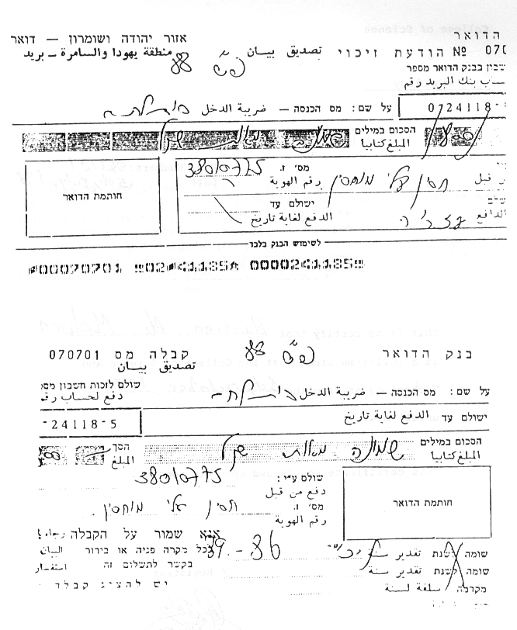
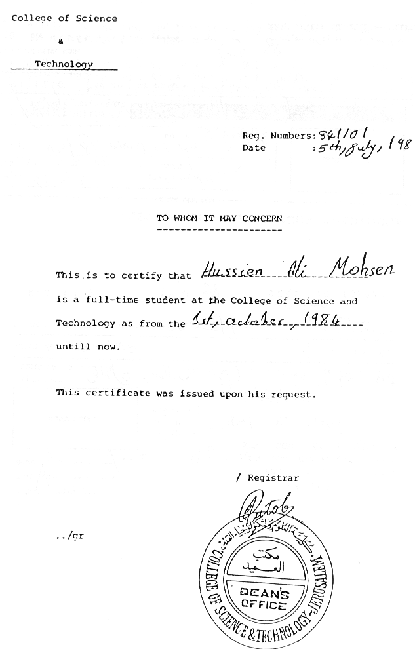

APPENDIX P: Excise Added Tax – Regulation 115a

"Should the Commissioner have reason to suspect that excise on transactions has not been paid, either because the dealer was thinking of leaving the area, or for any other reason, he (the Commissioner) is empowered to - (1) If an assessment was given the dealer according to Regulation (86) (assessment by best judgement) - demand, in writing, that the dealer immediately guarantee, to the satisfaction of the Commissioner, the payment of the excise specified in the assessment."

APPENDIX Q: Comparison of Tax Bracket Tables Under Jordanian and Israeli Law as Applied in the Occupied Territories

Table 1:
1966 Income in Jordan in 1988 Dollars | Total Taxes According to Jordanian Law in 1988 Dollars | Israeli Tax in 1988 Dollars
1838 | 0 | 0
6240 | 0 | 224
4040 | 240 | 2593
15840 | 577 | 4705
20640 | 1057 | 6817
25440 | 1777 | 9327
30240 | 2737 | 11877
35040 | 3937 | 14517
39840 | 5377 | 17157
54240 | 10417 | 25077
78240 | 20017 | 38277
102240 | 30817 | 51477

Note: Jordanian figures were calculated as follows: the 1966 Jordanian Dinar was multiplied by a rate of 3 Dollars to the Dinar and by 4 Dollars to take into account the reduction in buying power of the Dollar between 1966 and 1988.
Israeli figures were calculated as follows: the New Israeli Sheqel was divided by a rate of 1.6 to the Dollar.

From the comparison in the table, it can be seen that the tax incidence under Israeli law in the West Bank is much larger than under the 1966 Jordanian law. If we take into account the devaluation of the Dinar that took place after the introduction of tax brackets in 1988, the gap is narrowed by¯40-50%.

Table 2: Comparison of tax deductions on the West Bank in 1987 and 1988 in New Israeli Sheqels

Annual Deduction | 1987 | 1988
Resident | 1178 | 1050
Spouse | 709 | 630
Children | 118x5 | 105x4
Wage Earner | 944 | 840
Total Deduction | 3421 | 2940

In other words: In 1987, a family with five children was taxable its income was NIS 3,421. In 1988, the same family was taxable when its income was NIS 2,940. A family with a total income of NIS 4,830 in 1987 paid NIS 78 in taxes. The same family paid NIS 118 in 1988. A family in the second highest income bracket (49.5% marginal tax)76paid NIS 8,313 in taxes in 1987, but NIS 9,754 in 1988. That is, 17% more in nominal terms, but in real terms there was almost no change.

APPENDIX R: Testimony and Forms of Emil Uda Salameh

Emil Uda Salame:
Testimony and Forms

On July 19th, 1989, Yuval Ginbar of B'Tselem visited Beit Sahur. He took down the testimony of Emil Uda Salame who described the circumstances of his arrest on the charge of tax evasion. The interview was conducted in Arabic and is translated below. The rest of the testimonies are available in the offices of B'Tselem.

Soldiers came to my sewing-room. They asked to open and examine papers and books, and they wrote down the numbers of the machines. One of them, a VAT man (named Hannan) handed me summons for the next day. The soldiers took me in their car and Captain Yossi asked why I had not paid tax. I told him that during the Intifada one does not pay tax and if I pay damage might be done to me. They took me to the Military Government in Bethlehem.

We were about 60-70 people in the small stinking room equipped with dirty mattresses and blankets. We were there for four days. On Wednesday, between 11:30 and 11:45, Abu Rafiq and I were taken to the VAT Office in Bethlehem where we were questioned about why we had not paid. I received a bill for NIS 15,000 and was given a month's extension. I have no way of submitting reports or paying - only 3 months ago I was suspected of paying tax to the authorities and my car was burnt, so I am caught between hammer and anvil.

The army and the police are afraid of the stone-throwers and the other trouble makers, why shouldn't I be afraid? Until the beginning of the Intifada I paid tax. Now it is prohibited.

I went back to the Military Government, but despite the fact that they had given me a month's extension, Captain Yossi refused to release me. The next day we were taken to the Income Tax Office where they wanted the sum of NIS 42,000 from me on the basis of calculations I did not agree with (NIS 6 to the Jordanian Dinar). I asked for a month's extension until the matter with the VAT Office was cleared up, but they refused. (We were 10 residents of Beit Sahour). Finally they told me to go home, bring a checkbook and come back at 8:00 a.m. the next day. During the four days we were detained we did not wash and were not allowed to go out. I was required to pay NIS 25,000 as an advance. I said I usually pay 12.5% Income Tax after the VAT calculation and, moreover, the sewing-room was shut for a whole year, a fact they did not take into account. We went back to the prison, to the same room and stayed until 1:00 a.m. on Monday. Three of us were released after we cleaned the place.

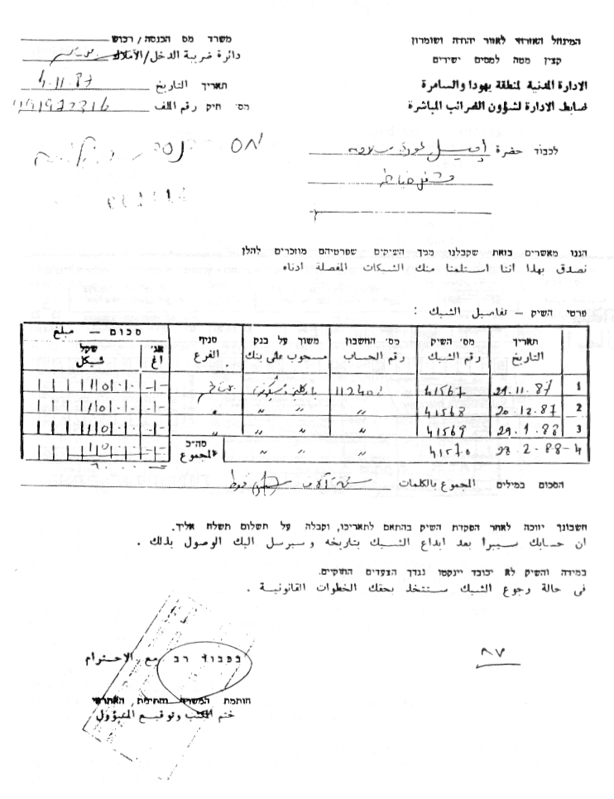
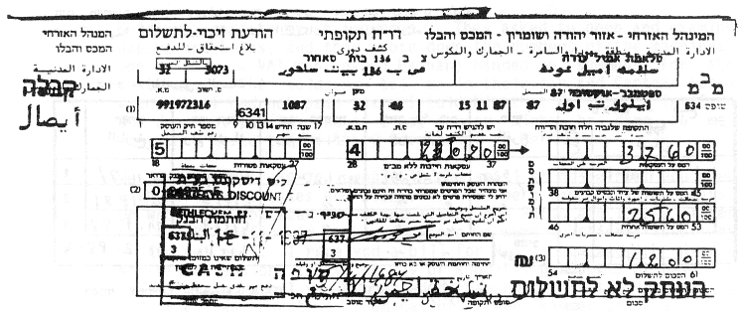

APPENDIX S: Testimony and Forms of Suhil Salem Hanuna

Suhil Salem Hannuna:
Testimony and Forms

Suhil Salem Hannuna, 42 years old, I.D. Card No. 939500658, has four children, works as a construction worker for the Israeli company ANIR in Binyanei Ha'uma, Jerusalem. Testimony was collected by Bassem 'Eid.
Mrs. Hannuna relates:

On October 26, 1989 at 10:00 a.m., soldiers and Income Tax and VAT officials came to the house. They knocked on the door and I let them in. My husband was not at home, and they started searching through closets and looking under mattresses. My husband arrived and showed them his salary slips. The officials claimed he was a contractor and not an employee.

They ordered a truck by radio. When the truck arrived they started loading it with property and furniture (the relevant forms are enclosed). When they had attached the property, the soldiers took my husband to the military base in Beit Sahour. The tax officials at the base contacted my husband's employer, who confirmed that Suhil works for him as an employee and gets a salary slip which lists all tax deductions. The officials did not believe the employer. Below our house is a sewing room which we let to someone. The soldiers asked where the key was. I said the place is being let and we do not have the key. The soldiers broke in, took 5 machines, and put them on the list they gave us and made us sign.

The soldiers' conduct was unreasonable. They opened the refrigerator to get things out of it, ate fruit they found there and started playing the piano we had, which they took as well. Each of the soldiers weighed himself on the scale in our house. The soldiers also searched my husband's body and found a check in his pocket which belonged to my husband's employer which my husband was supposed to use to purchase building supplies. The soldiers took the check.

My husband is summoned to the Income Tax office every day and they demand that he pay NIS 77,000. Every time he is summoned they ask him where the money to build our house came from. Suhil has engaged a lawyer to deal with the matter.

We have never received any warning or assessment for tax payment. We do not have a tax debt. My husband is salaried, and income tax and health insurance are deducted from his salary.

In the Hannuna home everything has been taken. The kitchen is empty, in the bedroom there is a closet and two beds, the living room is totally empty.

Mrs. Hannuna claims that the attached property is worth about 21,262 Jordanian Dinars -- about NIS 59,533,60.
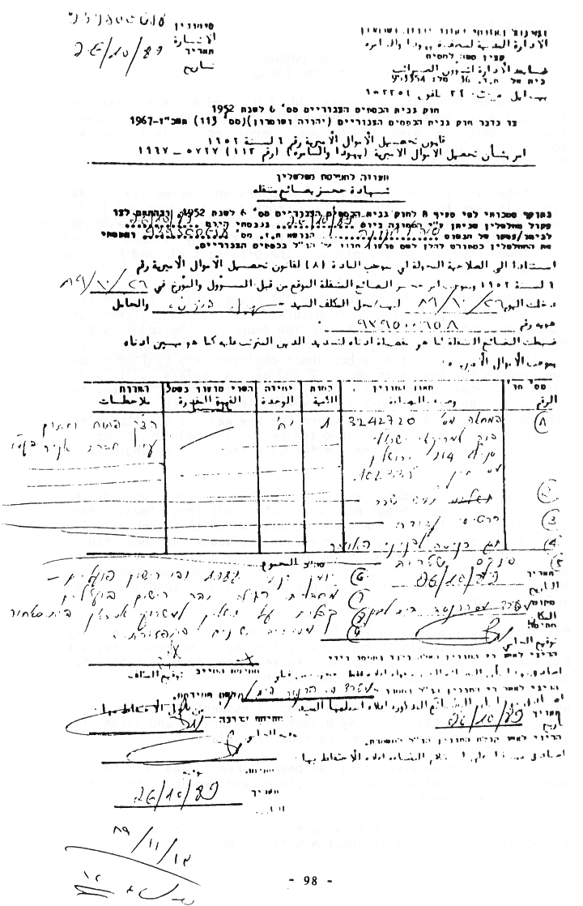
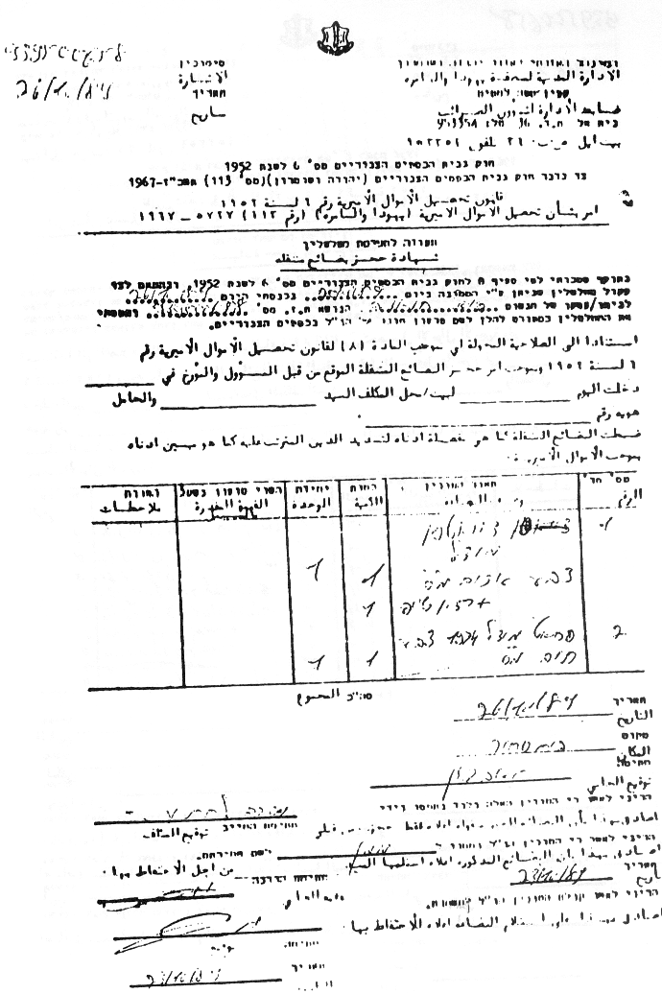
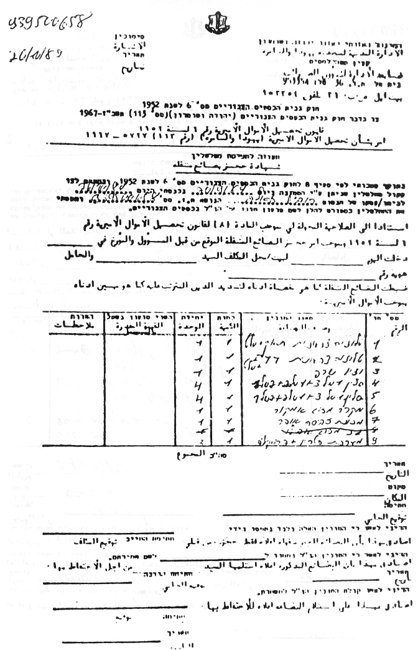
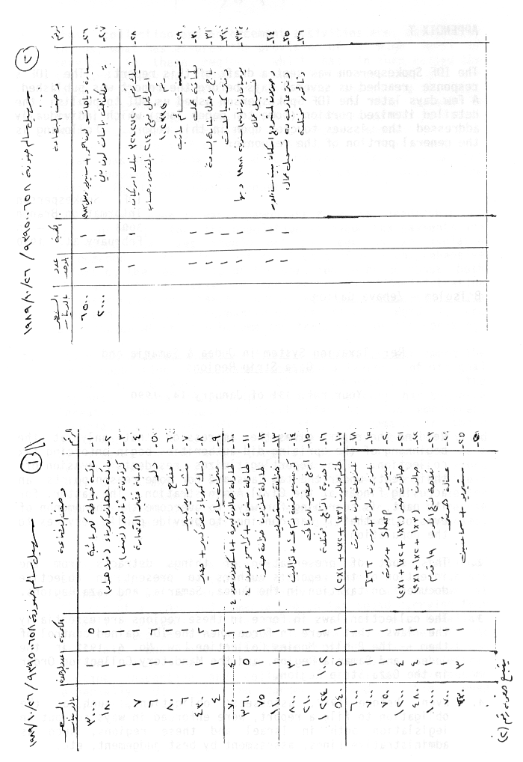
APPENDIX T: IDF Spokesperson's Response to This Report

The IDF Spokesperson was sent a draft of this report. The IDF's response reached us several days before the report was published. A few days later the IDF Spokesperson asked us NOT to publish the detailed itemized portion (some ten pages long) which individually addressed the issues touched upon in this report. Following is the general portion of the response:

IDF Spokesperson
Information Branch
3008 2 ¯ çé
February 31, 1990

B'Tselem – Zehava Gal'on

Re: Taxation System in Judea and Samaria and
Gaza Strip Regions

Your ref: 331 of January 14, 1990

1. Reading the report gives the impression that only at the beginning of the uprising did authorities begin enforcing tax collection. The report legitimizes residents' evasion of their debts under the tax laws and for some reason points an accusing finger at the Civil Administration. The latter, for its part, is searching for ways to overcome the phenomenon of evasion so that it can continue to provide public services to the population.

2. This sort of presentation of things detracts from the intention of the report's authors to present an objective document on taxation in the Judea, Samaria, and Gaza Regions.

3. The collection laws in force in these regions are essentially the laws that were in force when the IDF gained control of them -- the Public Monies Collection Law, No. 6, 1952 in the Judea and Samaria Region, and the Mandatory Collection Order in the Gaza Strip Region.

4. Even before 1987, assessees' obligations, such as the obligation to file a report, were enforced in ways set out in legislation, both in Israel and these regions, such as administrative fines, assessment by best judgement, etc.

5. These collection and enforcement activities are, among other things, what has assured the provision of a high level of services in these regions, which has in turn raised the standard of living there. Among these services are the construction of schools and hospitals, the paving of roads, welfare payments for the needy, etc. In this matter it should be emphasized that while international law permits a state administering territory considered combatant to make use of revenues from that territory for military purposes, Israel has NEVER done so, and ALL monies collected from the local population go solely to the administration of the regions for the residents' benefit.

6. Calls, heard even in early pamphlets from the leadership of the uprising, for the population to evade tax payments and disregard tax laws should not be seen as an isolated phenomenon. This is just one aspect of a comprehensive effort by the leadership of the uprising to bring about both the absolute collapse of the entire Civil Administration infrastructure and anarchy in the regions. These calls have been and still are accompanied by the attacks, murders, and destruction which have become the trademarks of the uprising.

7. Calls for tax evasion have found a sympathetic ear among the local population. To assure complete attainment of its goal -- that is, collapse of the Civil Administration in the regions -- the leadership of the uprising has begun to threaten the lives of Civil Administration employees, especially assessment officials, if they remain in their positions. As we all know, such threats have been fulfilled by attacks on people and property, as well as murders, as a result of which many Civil Administration employees, among them assessment officials, have been forced to resign their positions. Among other things, threats against letter carriers have caused those who remain in their jobs to refuse to handle official mail, including assessments, summonses, and the like.

8. Threats and attacks on assessment officials have continued even after the resignation of local ones. Less than six months ago, for instance, a Molotov cocktail was thrown at the car of a Judea and Samaria Region tax squad carrying four Israeli employees of the region's tax unit near Ramallah. The bottle caught fire, caused the death of one of the officials, and injured the three others. Given conditions created since the outbreak of the uprising, therefore, routine inspection and collection activities have become especially difficult and dangerous, and at times even impossible.

9. Although the uprising activists have failed to achieve their principal goal as described above, their measures have hurt the budget of the Civil Administration in both areas to some extent. This has found direct expression in its ability to continue providing services to the population. As a result, development in the area has been hurt, and the Civil Administration has been forced to find ways to remedy the resultant situation to allow it to continue fulfilling its obligations to the population.

10. Enclosed please find specific comments on each of subjects you raise in your letter.

Sincerely,

( ¯ )

Arik Gordin, Colonel
Head, Information Branch

 But see below – Other Sources of Revenue from the Territories.
See Appendix F – Letter from B'Tselem to Taxation Staff Officer and response.
See Appendix G – B'Tselem letters to Legal Advisor.
See Appendix A – Relevant provisions of the Hague Regulations.
See Appendix B – Principles of HCJ Abu Itta.
See Appendix E – List of orders concerning taxation; and Appendix H – data on principle tax laws in the territories.
See Changes in Local Tax Laws, p. 10; Appendix B - Principles of HCJ Abu Itta; Appendix C – Case comment by Prof. Yoram Dinstein; Appendix D – principles of expert opinion of Professor Gerard Von Glahn in the Abu Itta case.
These data were given to HK Haim Oron. See Appendix H.
 See Appendix I – the data was obtained from the State Revenue Administration and from the 1987 Statistics Quarterly for the Territories.
∗ See Appendix J – Tables of Collection Data from State Revenue Administration.
See Appendix K – Order 1262. This order applies on the West Bank. In the Gaza Strip there is a different version.
 See p. 19 below (conditioning services on payment of third party debts); and pp. 21-22 below (confiscation of identification cards and vehicle licenses).
Testimony was given to B'Tselem on December 7, 1989.
Testimony was given to the Hotline for Victims of Violence on April 21, 1989.
Testimony was given to B'Tselem on November 5, 1989.
See Appendix L – Petition of the Association for Civil Rights in Israel.
Testimony was given to the Hotline for Victims of Violence on July 9, 1989.
Testimony was given to B'Tselem on October 14, 1989.
See Appendix XIV – Letter from the Hotline for Victims of Violence to the Civil Administration and response.
Collected Income Tax Laws and Regulations (Judea and Samaria), 1988, pp. 24-25 (Civil Administration).
State Comptroller Report, Annual Report 37 for 1986 and for the 1985 Budget Year.
Testimony was given to the Hotline for Victims of Violence on November 12, 1989, after the man was beaten by Border Police soldiers because he did not have an identification card or substitute papers.
Kol Ha'Ir, July 7, 1989.
 From September 22 to 26, 1988; from October 11 to December 8, 1988; and from February 11 to 15, 1989;
Testimony was given to B'Tselem on July 1, 1989.
Testimony was given to B'Tselem on October 30, 1989.
See Appendix XVI – EAT Regulation 115A.
Testimony was given to Advocate Aliza Herman of the Hotline for Victims of Violence on June 1, 1989.
See Appendix XVIII – Testimony and forms of Emil Uda Salameh.
Testimony was given to B'Tselem on October 14, 1989.
Testimony was given to B'Tselem on November 4, 1989.
Testimony was given to B'Tselem on October 16, 1989.
See Appendix XIX – Testimony and forms of Suhil Salem Hanuna.
Proceedings of the Twelfth Knesset, Second Session, Vol. 7, p. 828.
In the authentic French text: "l'ordre et la vie publics".
Text taken from Selected Judgements of the Supreme Court of Israel, Volume VII (1983-1987.(
G. Von Glahn, "An Unofficial Expression of Opinion on the VAT Case Judgement," The Palestine Yearbook of International Law, Vol. IV, 1987-88.

