Impeding Medical Treatment and Firing at Ambulances

by IDF Soldiers in the Occupied Territories

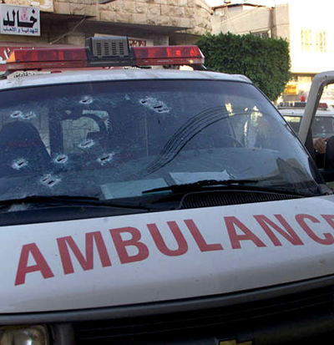

March 2002

Introduction

In the first two weeks of March 2002, the IDF conducted a wide-scale action throughout the West Bank and Gaza Strip, including entry of infantry and tanks into refugee camps. During this period, the IDF Spokesperson has frequently stated, as he has done since the al-Aqsa intifada began in September 2000, that the IDF does not injure innocent civilians and that it properly treats all humanitarian cases. For example, the IDF Spokesperson stated that, “Alongside the fighting, the soldiers are making every effort to avoid harming unarmed civilians, and avoiding as much damage as possible to their areas. The IDF provides humanitarian aid when needed and the forces have even been instructed to repair some of the damage the fighting has caused.” On 11 March 2002, the IDF Spokespersons stated that, ‘The IDF Spokesperson stresses that the IDF has no intention of harming the Palestinian population that is not involved in terrorist activities, and that the IDF will enable passage for humanitarian purposes.”

However, testimonies given to B’Tselem and information from other sources clearly indicate that these statements are baseless, and that the injury to the civilian population during these actions was unprecedented since the occupation of the Occupied Territories, in 1967. The IDF has fired at innocent civilians, including many children, caused extensive damage to private property, and more.

This report focusses on one aspect of the injury to the civilian population – prevention of medical treatment of the wounded and attacks on medical teams. For a period of two weeks, from 28 February - 13 March, IDF gunfire killed five Palestinian medical personnel who were on duty, wounded ten Red Crescent personnel, and damaged twelve ambulances, two of them totally.

The provision of medical treatment to the wounded and the immunity of medical teams and hospitals are fundamental principles of the laws of war, which bind the combatants in all circumstances. Since the beginning of the current intifada, B’Tselem has documented many cases in which the IDF violated these principles. These violations have increased significantly since 28 February 2002. IDF soldiers have fired at ambulances and prevented medical treatment to the sick and wounded, even leaving some of them in the field, where they bled to death. Also, the hospitals have been unable to function because of the damage to the electricity, water, and telephone infrastructure, and the blocking of access to some of them. As a result, the hospitals are unable to receive the wounded and sick, or obtain food and medicines.

On 8 March, the International Red Cross published a statement in which it condemned IDF shooting at ambulances and medical teams. The statement emphasized that the Red Crescent ambulances that were hit were properly marked and that their movement had been coordinated with the Israeli authorities.

This report presents testimonies on IDF acts of shooting at ambulances and medical staff, preventing the sick and wounded to cross at checkpoints, and damaging hospitals. At the end, B’Tselem relates to Israeli officials’ contentions that seek to justify these acts.

This report was published on 14 March 2000, during the IDF actions in refugee camps throughout the West Bank and the Gaza Strip. Since then, the IDF began Operation Defensive Shield, in which IDF troops entered Palestinian villages and refugee camps. Reports given to B’Tselem indicate that the soldiers have committed acts of much greater severity and frequency than those described in this report in each of the relevant areas – preventing the evacuation of the wounded, forbidding ambulances to pass, and impeding hospitals from functioning properly. This report does not discuss these incidents.
Firing at Ambulances and Medical Staff

Since the beginning of the al-Aqsa intifada, B’Tselem has documented cases in which IDF soldiers fired at ambulances and medical staff on their way to evacuate the wounded. Since 28 February 2002, there has been a significant increase in the number of such cases, and they have become almost routine. The gunfire has killed and wounded medical team members, and damaged ambulances. The gunfire has also made it impossible for the medical teams to evacuate the wounded to hospital, and some of the injured have bled to death.

The IDF also fires at ambulances and medical teams where passage of the ambulances has been coordinated with IDF officials, For example, Dr. Waal Qadan, director of the red Crescent Society in the Occupied territories, informed B’Tselem that, during the IDF’s incursion into Ramallah, agreement was reached with the army that Red Crescent ambulances would be allowed to move about when accompanied by a Red Cross vehicle. Despite this, on 12 March 2002, at about 6:30 P.M., IDF soldiers fired at a Red Cross vehicle that was accompanying an ambulance, striking it twice. As a result, the medical teams halted their work until the following afternoon, when the movement of ambulances was once again coordinated with the army. During that time, the Red Crescent received forty-two calls to evacuate wounded to which they could not respond.

‘Anan Khalil a-Rahman Qadri, a hotline coordinator for the Palestinian Red Crescent in Nablus, told B’Tselem about an event that took place when IDF forces entered the Balata refugee camp

On Thursday [28 February], I started work early in the morning. Around 3:30 P.M., I went with the ambulances to transport people who had been wounded by the Israeli shelling of the Balata refugee camp. Palestinian residents had notified us that people had been wounded. When we got to the camp, the army fired at the ambulances and the medical teams. In one instance, we were notified that a person had been wounded in the abdomen, and that he was in a house in one of the alleyways in the eastern part of the camp, where the Israeli army was located. When we got to the area, the Israelis fired at us and we couldn’t enter the neighborhood. The soldiers clearly saw that it was an ambulance, but they fired at us nevertheless.

‘Emad ‘Ali, an ambulance driver, described a similar occurrence that took place when the IDF entered Khirbat Khaza’a, which is located southeast of Khan Yunis:

On Friday morning [8 March], at 1:45 A.M., Red Crescent headquarters received a call following the IDF incursion into Khaza’a. The medic, Na’im Abu ‘Amar, and I reached the area within a few minutes. The residents were standing outside their houses. They said that the army had invaded the southern part of the village, and that nobody had been wounded yet.

I stopped the ambulance opposite the mosque next to the square. As I did, Ali, the director at Red Crescent headquarters, called and told me that there was a wounded person opposite the a-Shuaf medical clinic. When I was south of the square, while on the way to the scene, with no warning whatsoever, shots were fired at me. Bullets hit the front of the ambulance. I stopped immediately and returned in the direction of the mosque…

A short while later, residents said that there was another wounded person, and they explained where he was. I drove carefully, because there was intense firing going on. An elderly man who was standing on a side road called to me. We drove over to him and we saw a person in uniform lying on the ground. Muhammad a-Samiri and I got out and picked him up. Another fellow helped us put the wounded into the ambulance. When I began to move, the soldiers opened intense fire at us. The firing came from the east. The fellow who had helped us was standing about half a meter from the door of the ambulance. He suddenly fell to the ground. The side door of the ambulance was still open. Muhammad stood there like a statue, and I shouted to him to bring the fellow. He quickly picked him up and put him into the ambulance. I rushed to Nasser Hospital.

Many residents were standing at the entrance to the hospital. They helped us to remove the two wounded men. It was then that we realized that they were dead. A few people grabbed me and asked about the number of wounded. One of them asked if I could pick up a person who had been wounded in Khaza’a. I took him to the front of the ambulance and showed him the hole so that he could see for himself that the shot could have killed me. He was horrified and said nothing.

During the army’s actions in the Occupied Territories in the first two weeks of March, IDF gunfire killed five medical staff personnel:

- On 4 March, Dr. Khalil Suliman, director of the Red Crescent in Jenin, was killed by gunfire at an ambulance in which he was travelling on the way to evacuate wounded in the Jenin refugee camp. Two other members of the medical team who were with him the ambulance were wounded. IDF soldiers also fired at an ambulance, wounding two medics, that had come to treat the wounded in the first ambulance.

- On 5 March, Sa’id Shalayal, a medic, was killed by gunfire at an ambulance in which he was travelling in the Jabalya refugee camp in the Gaza Strip.

- On 7 March, Ibrahim As’ad, an ambulance driver for the Red Crescent in Tulkarm, was killed by gunfire at his ambulance while on his way to evacuate wounded from the Tulkarm refugee camp. The gunfire also wounded three other members of the medical team in the ambulance.

- On 7 March, Kamel Sallem, an UNRWA employee, was killed in Tulkarm by gunfire at an ambulance that was on its way to evacuate wounded.

- On 8 March, Dr. Ahmad ‘Otman, director of al-Yamama Hospital, in el-Khader, Bethlehem District, was killed by tank fire near the Deheishe refugee camp. Dr. ‘Otman was on his way to Beit Jala to pick up medicines. The IDF Spokesperson confirmed that Dr. ‘Otman’s travel had been coordinated with the IDF. He contended that the gunfire resulted from the fact that “some soldiers, who had not been informed about the approval that had been granted ,saw a vehicle speed toward them, and they fired at the road to stop it. When the vehicle continued, the soldiers fired at the vehicle, killing the driver.”

Killing of Dr. Khalil Suliman, 58, director of the Red Crescent in Jenin

On 4 March, Dr. Khalil Suliman, director of the Red Crescent in Jenin, was killed by IDF gunfire at an ambulance in which he was travelling. The IDF Spokesperson contended that:

During the activity of IDF forces in the Jenin refugee camp, a Palestinian Red Crescent ambulance charged an IDF force.
The force opened small arms fire at the ambulance, which exploded… the initial investigation into the incident found that the soldiers acted out of self-defense, after the ambulance charged towards them at a high speed from an area in which there were exchanges of fire.”

Testimonies given to B’Tselem that are presented below paint a different picture. The ambulance did not explode and did not endanger the lives of the soldiers, but was on its way to evacuate wounded. Also, soldiers fired a grenade at it and did not use small arms fire. The IDF Spokesperson’s statement also hints that the ambulance contained explosives. However, the explosion was apparently caused when the oxygen tank in the ambulance was struck.

Furthermore, the testimonies of Dr. Tareq a-Rud, a physician at the hospital in Jenin, and Dr. Waal Qadan, director of the Red Crescent Society in the Occupied Territories, indicate that the entry of the ambulance into Jenin was coordinated with the army, and the soldiers in the camp should have known that the permission to enter had been given. Therefore, the soldiers inside the camp should have expected the ambulance.

Mahmud As’ad, a medic for the Red Crescent in Jenin, who was summoned to the Jenin refugee camp to treat the wounded who were in the ambulance that had been struck, told B’Tselem that soldiers also fired at the ambulance in which he was travelling:

When we reached about twenty meters from the ambulance that had been hit, we were struck by gunfire that was aimed at the roof of the ambulance. Later, I was informed that the gunfire had come from a house about ten meters away, where Israeli soldiers were located. A large number of bullets hit the ambulance, and the fragments struck me in the head and right arm. Ibrahim Yasin was also injured in the head by fragments. We screamed out of fear and panic. Luckily, the ambulance driver had not been hit, and we managed to rush away from the scene.

We drove about fifty meters, and then the firing stopped. I am a resident of the Jenin refugee camp and I know all the roads. We went along a relatively safe road until we got to the government hospital. As I stated, we did not mange to get the to the ambulance that had been hit.

Testimony of Muhammad Ahmad Muhammad ‘Omer, 44, married with nine children, manual laborer, resident of the Jenin refugee camp

I live in the western neighborhood of the Jenin refugee camp, next to the ‘Abdullah ‘Azzam mosque. The house is located at a high altitude and overlooks large sections of the camp. On Thursday [28 February], large numbers of Israeli troops surrounded the camp. The next day, at 10:30 A.M., some forty soldiers whose faces were painted came to the house and demanded that I open the door. Without using force, they took over half of the first, second, and third floors of the house. They ordered all of us to go into one room on the first floor and to stay there. Afterwards, they ordered me to accompany the commander on a search of the house. They conducted the search and found nothing. The soldiers made openings in the shutters through which they could shoot. They fired until 5:00 P.M. Then they left the house and went to another house.

On Monday, at 10:00 A.M., the soldiers returned to my house. The commander, Eitan, ordered me to take all of my family into the room where we had been the previous time. Then he threatened me with his weapon to get me to open the doors of the houses of my neighbors Nasser Abu al-‘Eiz, Yusef Lahluah and some others.

When I returned home, I saw that some twenty soldiers had entered the house and taken over the second and third floors. I stayed with my family in the one room. I spoke with a Druze soldier named Ashraf. At 12:30 P.M., he called me, and I went to where he was on the second floor. The commander stood there and held a picture of my son ‘Ala holding a weapon. The commander asked me about the weapon. I told him that it belongs to the Palestinian Authority, and that my son uses this weapon to perform his duties in Ramallah. After a brief argument with Eitan and Ashraf, I was asked to go back to the room.

At that moment, I heard the siren of an ambulance that was approaching the house from the west and the sound of gunfire from the room on the west side of the house. Commander Eitan rushed into the bedroom from which the soldiers were firing. I was standing next to the door of the room. It was open, and I saw the commander stand next to the window on the north and fire a grenade from his weapon, an M-16, at the ambulance, which was around fifty meters from the house. I managed to see the ambulance drive fast in reverse for about ten meters. I asked the commander what he was doing, and he said that armed Palestinians had fired at the ambulance. I saw the grenade strike the front windshield of the ambulance.

I was forced to go back to the room, and on the way I heard a person scream “Allah Akbar.” About fifteen minutes later, I heard a loud explosion, and from the window of the room we were in, I saw the ambulance go up in flames. We began to scream because the ambulance was about ten meters from the room. I asked the army doctor who was on the lower floor to let us go to another room, one further away from the shooting. I also asked him what was happening. He answered me in Arabic: “May Allah have mercy on him.”

Ten minutes later, I heard an ambulance and fire engine approach the area. I heard the soldiers shouting at them, and then I heard the sound of intense gunfire.

We remained imprisoned in the room until 9:30 P.M., when the soldiers left. While we were in the room, we listened to the news and discovered that Dr. Khalil Mahmud Suliman, director of the Red Crescent, had been burned in the ambulance. I was told that two of the ambulance staff had been thrown out the rear door of the ambulance as a result of the blast, and that the ambulance had crashed into our neighbor’s house. I also heard that the ambulance staff had suffered severe burns over their entire bodies.

In the morning, I went along with dozens of residents to see the ambulance, which was still under the house. It had been completely burned, and some of the doctor’s bones were scattered on the driver’s seat.

Killing of Ibrahim As’ad, 35, ambulance driver of the Red Crescent in Tulkarm

Testimony of Mahmud Hussain Najib al-Bajoui, age 32, married with five children, first-aid officer with the Red Crescent in Jenin, resident of Yabed, Jenin District

Since 1995, I have worked at the Red Crescent Society’s center in Jenin as a first-aid officer. My job is to accompany ambulance drivers and provide first aid to the sick or wounded during the time they are being transported to the hospital.

On 7 March, at 5:00 P.M., we received a call from the first-aid station in Tulkarm, a branch of the Red Crescent. They requested that we come and provide assistance in evacuating those who had been wounded when Israeli took over control of Tulkarm and the refugee camp, as many had been wounded and killed. At 6:30 P.M., the first-aid station received approval from the Israelis that the ambulances could come to the refugee camp. We set out toward the camp with two ambulances. Ibrahim Assad and a medic named Safiya were in the first ambulance. I was driving the second ambulance. A young man named Ra’id was with me in the ambulance.

I followed Ibrahim, and after driving for about four hundred meters we reached an intersection in the eastern portion of the city, approximately one thousand meters from the Tulkarm refugee camp. We turned on our sirens and the lights in the ambulances. A tank was standing in the intersection, and as we approached, it fired one long round in the air. I understood that to be a signal from the soldiers that they wanted us to move back. We backed up about fifty meters and then, unexpectedly, the tank began moving toward us quickly. As soon as we saw this, we stopped immediately because we thought that the soldiers wanted to check the two ambulances.

The tank stopped at a distance of only two meters from the ambulances and started firing long rounds of fire at the second ambulance. I realized that I had been wounded. I opened the door and hid under the ambulance. From there I could seen the other ambulance, and I could see Ibrahim’s head resting on the steering wheel. The ambulance’s horn was honking non-stop because his head was lying on it. His head was covered in blood, and I realized that he was dead. I saw the tank turn around and move towards the left side of my ambulance. The whole time, the firing continued both from the tank and other nearby sources.

I crawled under the ambulance and jumped over the fence that was about two or three meters away from the road. I started moving quickly away from the area. I was crawling and walking, and the whole time the soldiers fired in my direction. I was sure that I would get hit again, but I decided nonetheless to take my chances and run away. I went into the alleyways of the old market. Ra’id, who had been in the ambulance with me, also made it there, as did the medic Safiya, who had been in the other ambulance. Her left shoulder was lightly injured from two pieces of shrapnel.

My co-workers at first-aid station in Tulkarm carried me to the hospital that is across the street from the station.

Preventing Medical Treatment

Israel’s sweeping restrictions on Palestinian movement since the beginning of the intifada affect almost all areas of Palestinian life in the Occupied Territories. One of the more serious consequences is the impediment to access to medical treatment. B’Tselem has documented dozens of cases in which soldiers delayed wounded and sick people and women in labor on their way to hospitals, or prevented them from crossing through checkpoints. Since the beginning of the intifada, September 2000, at least twenty-seven Palestinians have died after soldiers delayed or prevented them from reaching the hospital.

In response to claims about delaying the sick and wounded at checkpoints, the IDF Spokesperson again contended that the IDF has clear procedures that require soldiers stationed at checkpoints to allow Palestinians requiring medical treatment to pass. However, these procedures are not implemented. Testimonies given to B’Tselem by soldiers who served in the Occupied Territories indicate that, contrary to the IDF Spokesperson’s statements, the soldiers are often not even aware of these procedures, and that the decision on letting the sick and wounded pass is left to the soldier in the field.

During the IDF actions in the beginning of March, the impediments to providing medical treatment were much greater because of the increased restrictions on Palestinian movement in the Occupied Territories and the placement of new roadblocks. Soldiers prevented ambulances from reaching and treating the wounded. When ambulances managed to get to the wounded, the soldiers did not let them reach the hospitals. Residents who came to the checkpoints were turned back, and chronic patients were unable to reach the hospital to obtain the medical treatment they required.

Testimony of Sid Muhammad Hassan Najar, 24, single, medic with the Red Crescent Society in Jenin, resident of ‘Inbata, Tulkarm District

I have been working as a medic with the Palestinian Red Crescent Society in Tulkarm for four years. I go in the ambulances to care for the wounded and evacuate them to the hospital.

On the morning of 7 March, a large number of IDF forces, with helicopters hovering above, entered the Tulkarm refugee camp. Immediately after the incursion, we received a call that there were many wounded and dead inside the camp. I spoke with the DCO [District Coordinating Office] and the Red Cross to coordinate our entrance into the camp, but it took a long time. As the number of wounded was rising, we couldn’t wait any longer to receive approval, and Red Crescent headquarters decided to send ambulances to the camp without IDF approval. The ambulances set out to the refugee camp to treat the wounded, but were held up by IDF soldiers, who searched the medical personnel. The soldiers asked the medical staff to hold up their hands and stand next to the wall. The soldiers then checked their upper bodies, while aiming their weapons at them. The ambulances were held up for over forty-five minutes because of the searches, and in some cases they were forced to head back and find an alternative route.

At 6:00 PM, we received a call about two wounded. One was in the southeast part of the camp, and the second in the eastern portion near the entrance to the village of Danaba. We went through the back entrance of the village and reached the entrance of the refugee camp. We passed a number of tanks as we were driving, but they did not stop us.

We reached one of the injured. He was forty-six years old and had a serious back injury. We put him into the ambulance and drove toward the hospital, following the same route on which we had come. At the second entrance to the village of Danaba, which is next to the neighborhood at the northeast of the refugee camp, we were surprised to see that the tanks that we had previously passed were now blocking our path. The soldiers pointed the weapon on the tanks at the ambulance. After waiting for about two minutes, during which we informed the Red Crescent headquarters of this development, one soldier came out of the tank and told us to go back from where we had come. I should emphasize that there is no other route to the hospital.

We told the soldier that we were transporting someone who was seriously injured and bleeding, and that we had to take him to the hospital immediately. But the soldier did not listen to us, and he screamed at us in Hebrew “Go away.” He threatened to shoot us, and aimed his gun at us. We backed up a few meters and asked the soldier to let us wait there while we coordinated with the DCO and received permission to pass. We stood at a distance of about one hundred meters from the soldiers and waited for about fifteen minutes. We then got an answer from the Red Crescent headquarters that the Israelis refused to give us permission to pass. As we were waiting, the patient died. We told the Red Crescent headquarters, and were instructed to wait until we received a response form the Israeli side. We waited for an hour, during which we heard that a medic who was in an UNRWA ambulance had been killed. We were terrified. After about ten more minutes, we were informed that soldiers had shot at a Red Crescent ambulance and that four or five medics had been injured.

We backed up about thirty meters. We then left the ambulances and went into a nearby house to hide. We left the corpse inside the ambulances. We spoke with the Red Crescent headquarters in Shanit and they informed us that the Israeli side refused to let us passed and told us that they were firing on all the ambulances. We were told that the Red Cross was also in Tulkarm and was trying to coordinate our passage with the Red Cross in Jerusalem. We stayed in the house all night.

The Red Cross informed us that their vehicle would come by in the morning and escort us back to the Red Crescent headquarters. We waited until morning, and at 3:30 P.M. on Friday [March 8], they told us that we could pass with the Red Cross escort. At 4:00 P.M., a Red Cross ambulance reached us and escorted us to the hospital in Tulkarm. The corpse was bloated because it had been lying in the ambulance for twenty-two hours.

Testimony of Ziyad Salah Muhammad al-Jiyushi, manual laborer, resident of Kur, Tulkarm District

I live in the village of Kur, which is about seventeen kilometers southeast of Tulkarm. My wife Rana was in her ninth month of pregnancy. On 5 March she had a checkup with the doctor and he told her that the fetus was doing well and that there were no medical problems. Three days later, at around 8:00 PM, my wife asked me to take her to her parents’ house. She was feeling pains and thought that she might give birth that night. I went with her to her parents’ house in Haja, which is about forty kilometers from Kur.

The next day [9 March] at 6:00 A.M., my wife was suffering from strong pains and her mother told me that she was about to give birth. She asked me to bring my cousin 'Abd a-Rahim’s car so that we could take Rana to the hospital. The road to the hospital was closed because of the Israeli checkpoints, and we decided to go to the house of the midwife in the village of Azun. At around 6:30, we reached Azun and went to the house of Suheila Juda, the midwife. At around 7:30 A.M., Rana gave birth, but the baby was stillborn. At around 8:00 A.M., Rana’s condition began to deteriorate and we decided to take her to the village doctor.

The doctor checked my wife and told me that I had to take her to the hospital as she was weak and tired. We went in my cousin’s car on a hilly path towards Qalqiliya. We drove to Asla and then to Azbat a-Tabib. We continued via Nabi Elias until we reached the IDF checkpoint at the entrance to Qalqiliya.

The soldiers who were standing at the checkpoint told us to turn around and go back where we had come from. My cousin and I got out of the car and told the soldiers in Hebrew that we had with us a woman who had just given birth to a stillborn. I told him that she was my wife and that she was in a bad state. I asked them to look in the car, but they refused. We started screaming that my wife would die if they wouldn’t let us pass, but the soldiers refused and told us mockingly “May Allah have mercy on you.”

My cousin continued speaking with them and I went to my wife. She held on to my hand tightly and said to me, “Do something. I am so tired.” Her hand fell out of mine, and she did not say anything more. I started screaming at the soldiers that my wife had died because of them.

About twenty-five minutes after we got to the checkpoint, the Israeli soldiers summoned an ambulance via the DCO. After about seven minutes, a Red Crescent ambulance reached us. The soldiers still wouldn’t let us go into Qalqiliya. One of the medics reached us and checked Rana. He put an oxygen mask on her, but could not revive her. He took her to the Red Crescent ambulance and it took her to the hospital in Qalqiliya. At around 9:30 A.M. on Saturday morning, the doctors pronounced her dead.

Testimony of Dr. ‘Azzam a-Rahman ‘Abdullah Nazal, 27, single, physician at the Jenin Governmental Hospital, resident of Qabatiya, Jenin District

The dialysis department at the hospital treats thirty-seven patients, who come from throughout the Jenin district. Some patients come three times a week, while others come twice. A few come daily. Only five of the patients live in the city. The others live in villages and have to cross Israeli checkpoints to get to the hospital.

Even before the army’s action in Jenin and in the refugee camp, patients encountered problems and delays at checkpoints, and had to spend hours at checkpoints on their way to hospital. Since 28 February, the situation has worsened, and these patients simply have not been able to reach the hospital. Whether they live inside the city or outside makes no difference - they do not receive their treatments on schedule. We were informed that some of them have to travel to Nablus for dialysis treatment. Others are forced to stay at home, and risk medical complications which are potentially fatal.

On 28 February, thirteen patients were scheduled for treatment at the hospital, and only three managed to make it here. The others remained at home, or tried to get to the hospital in Nablus. The three patients who reached the hospital couldn’t leave the hospital because of the siege imposed on the hospital by Israeli tanks. The patients had to wait for four to five hours until an ambulance could take them home.

One patient, Sila al-Kharthiya, who is sixty-years-old, couldn’t get to the hospital until today, four days after he was scheduled for treatment. He arrived in serious condition, which stabilized only after he was treated. Because of the checkpoints, some patients still have not been able to get here at all to receive treatment. This greatly jeopardizes their health.

Harm to Hospitals

The IDF actions in the Occupied Territories in the beginning of March impeded the functioning of several Palestinian hospitals. Some of the harm resulted from damage to infrastructure, from the siege on the hospitals by Israeli tanks that were positioned at their gates, and from shelling by tanks. As a result, even when ambulances were able to evacuate the wounded, they were unable to transport them to the major hospitals for treatment.

Jenin Governmental Hospital

Testimony of Dr. Tareq Ahmad Salah Abu a-Rud, 43, married with four children, resident of Jenin, obstetrician at the Jenin Governmental Hospital

On 28 February, the Israeli army invaded Jenin with tanks. Some were on the streets and others closed off the Jenin refugee camp, which is near the hospital. The siege on the camp blocked the way to the hospital from both the east and the north, and severed the camp from Jenin Hospital and other hospitals.

At 2:00 P.M., the tanks concentrated around the hospital. One of them parked less than five meters from the main entrance of the hospital, opposite the emergency room. Three tanks stopped at the southern entrance, which faces the entrance to the refugee camp, and other tanks stood about five meters from the morgue. The siege was hermetic, with the army preventing movement to and from the hospital. No ambulances could leave, and the hospital staff inside the building couldn’t move from the emergency room to the wards because the tank’s machine gun was aimed at the emergency room.

Just before the siege, a person who had been severely wounded in the head arrived at the hospital. He had to be taken to Rafidiyeh Hospital, in Nablus. He was put in an ambulance that was to take him there. Then the tanks arrived. The ambulance driver got out and went into one of the hospital’s wards. He tried to get back to the ambulance several times, but the tank that was positioned at the southern corner of the hospital opened fire at him. We coordinated matters with the District Coordinating Office, and after a delay of about an hour, we managed to transport the wounded patient to Nablus.

Three persons who had been killed were brought to the hospital shortly before the tanks arrived. We wanted to move them to the morgue, which is located in the southern part of the building. While the hospital staff was moving them, they were surprised to see a tank about five meters from the room open fire. The staff was unable to reach the morgue. About two hours later, I left the hospital with two hospital employees. I was dressed in physician’s clothes. The soldiers apparently saw the uniform, so we managed to take the dead to the morgue.

The hermetic siege lasted until midnight. Then the tanks moved back, to a distance of about thirty, forty meters from the hospital. Only then did they let the ambulances move. During the siege, no wounded arrived at the hospital, but as soon as ambulances were allowed to move, more than twenty wounded arrived all at once.

During the siege, one of the tanks knocked over an ambulance that was stopped on the side of the road next to the hospital’s gate. The tank also ran over a physician’s car and totally demolished another car as well.

On Sunday morning, the tanks returned to Jenin and invaded the camp. From 5:00 P.M. to 6:00 P.M., they surrounded the hospital. One of the tanks fired a shell at an ambulance that had been struck by a tank on Friday, burning it completely. The director and deputy director of the hospital were unable to enter the hospital. They finally succeeded – by coming in ambulances – but it took more than two hours. The tanks continued to surround the hospital until Tuesday evening.

On Monday, the army attacked the camp with great force, killing six and wounding more than forty people. During the daytime, no ambulances managed to reach the hospital. Only during the twenty-five-minute period between 2:45 P.M. and 3:10 P.M., and following coordination with the Red Cross, could ambulances get through to the camp and evacuate the killed and wounded. During this period, three of the killed and twenty-five of the wounded were brought to the hospital…

Later, ambulances did not wait for coordination with the Red Cross. The medical teams treated the civilians despite the intense gunfire, evacuated the medical team who were with Dr. Khalil, and brought them to the hospital. As for Dr. Khalil, nobody could get close to the ambulance, which was in flames for more than ninety minutes. It wasn’t until 5:00 P.M. that they managed to bring in his body.

The siege on the hospital lasted until around 9:00 P.M. and there were about two hours of very intense firing. At 9:30 P.M., a second cease-fire was declared and the tanks withdrew to the entrances to the city. The tanks continued to fire until about 11:00 P.M. Between 7:00 P.M. and 8:00 P.M., there was gunfire on the operating room, which is on the first floor, while doctors were operating on one of the wounded. They had to leave the room and hide until the shooting stopped.

While the siege took place, several snipers stationed on houses near the hospital fired at the hospital, which paralyzed all movement around the complex. Palestinian officials decided that armed Palestinians would not go near the hospital, so as not to give the Israeli snipers an excuse to fire at them and cut off movement within the hospital.

Ramallah Governmental Hospital

During its operation in Ramallah, the IDF cut off the supply of electricity and water to the city, which impeded the activity of the governmental hospital in the city. The hospital is a major hospital in the West Bank, to which patients are brought from elsewhere in the Occupied Territories. Among the effects of the IDF action was a shortage in the supply of oxygen to the hospital. The supply was renewed only following the appeal of the Association for Civil Rights in Israel to the OC Central Command, Major General Yitzhak Eitan.

The comments made to B’Tselem by Dr. Musa Abu Hameid, the director of hospitals in the West Bank, indicate that, as a result of the IDF action, the hospital in Ramallah suffered problems similar to those encountered by the hospital in Jenin:

On 11 March 2002, at 1:30 A.M., Israeli tanks entered Ramallah and stopped near the hospital. From the hospital’s gates, they opened fire at the Qadureh refugee camp. At about 3:00 A.M., machine-gun fire shattered windowpanes at the hospital. A battle ensued with six tanks that were a few meters from the hospital’s gates. I do not understand why the soldiers chose to fight so close to the hospital.

During the army’s action, the hospital’s electricity, water, and telephones were cut off. The hospital had to use its generator. The main problem was the shortage of water. UN personnel brought us bottles of water, but there was not enough water for drinking or even for the operating team to wash their hands before surgery. It took forty-eight hours for oxygen tanks to reach the hospital, and that was only after the Red Cross and lawyers intervened. The oxygen tanks had to come from Jenin, as is usually the case. The Red Cross brought us food, which was in short supply in the hospital.

At the Ministry of Health, we coordinated our efforts with Palestinian Civil Defense. After coordinating matters with the Israelis, Civil Defense provided us with the minimum supplies necessary to operate the hospital.

Because tanks were surrounding the hospital, the wounded in the city were unable to reach the hospital, and they were evacuated to al-Raiyeh al-Arbiyeh Hospital, which is a small, private hospital that has only one surgeon. The hospital couldn’t handle the great number of wounded. We had to send our physicians from the main hospital to assist.

The hospital was unable to care for regular patients. Two people also died in their homes, and it took twenty-four hours before we could bring them to the hospital morgue.

International Humanitarian Law and the State’s Contentions

Israeli officials acknowledge the immunity of ambulances and medical teams, and the duty to allow evacuation of wounded. However, they claim that two narrow exemptions in international humanitarian law justify the injuries described in this report.

International humanitarian law grants broad, sweeping protection to medical teams and the wounded. “Civilian hospitals … may in no circumstances be the object of attack, but shall at all times be respected and protected by the Parties to the conflict.” This protection also applies to “persons regularly and solely engaged it the operation and administration of civilian hospitals, including the personnel engaged in the search for, removal and transporting of and caring for wound and sick civilians…” The Convention also provides that parties to the conflict “shall facilitate the steps taken to search for the killed and wounded…”

International humanitarian law recognizes exceptions to these rules. The first exception states that the “protection to which civilian hospitals are entitled shall not cease unless they are used to commit, outside their humanitarian duties, acts harmful to the enemy.” The commentary to this article states that the wording was intended to stress the exceptional character of the provision and make it clear that this exception applies in only one case. The second exception relates to delay in evacuating wounded, and states that, in extremely exceptional circumstances, when hostilities and military considerations do not enable medical teams to enter the area and evacuate the wounded, a party is allowed to delay the evacuation of wounded. However, the delay must be as short as possible.

Physicians for Human Rights petitioned the High Court of Justice, demanding the IDF clearly instruct soldiers not to fire at ambulances and to allow the evacuation of wounded. In its response, the state provided a detailed and comprehensive survey of the provisions of international humanitarian law relating to providing medical treatment during hostilities, concentrating on the exceptions to these rules that were presented above. The state concluded that, “There is no defect in the orders given to soldiers in this matter, and they conform to international law.”

The state made almost no mention of the incidents that took place in the Occupied Territories when IDF forces entered the refugee camps. It contended that it did not have sufficient time to investigate the details of the cases presented in the petition. However, by emphasizing the exceptions set forth in international humanitarian law, and concluding that the orders given the soldiers are proper, the state appeared to argue that the extensive impediments to providing medical treatment in the Occupied Territories was lawful.

The sweeping application of the two exceptions ignores the facts on the ground. The state’s first contention is that the Palestinians use ambulances for purposes unrelated to providing medical treatment. “More than once, the Palestinian side has used ambulances to transport armed combatants from place to place, smuggle armed wanted persons, smuggle weapons, and the like.”

This contention has been raised many times since the current intifada began, primarily during the first two weeks of March. For example, when IDF forces entered Balata refugee camp, Col. Aviv Kochavi, commander of a paratroop division, stated that, “The soldiers witnessed a very serious and grave phenomenon. The Palestinians used ambulances to hide gunmen. The soldiers witnessed at least twenty incidents, some of which were documented, of armed Palestinians getting into ambulances. They did not open fire towards the ambulances out of concern that innocent injured civilians were also inside them.” In its response to the Physician for Human Rights petition to the HCJ, the state raised a similar contention regarding the delay in allowing ambulances to enter the Tulkarm refugee camp:

First, it was found that, during the action in Tulkarm, security officials identified armed Palestinians getting into Red Crescent ambulances. Following this, an order was given to check ambulances before allowing them to pass. As mentioned above, this was not the first time that the Palestinian side used ambulances to assist in its war against the IDF. In the past too, ambulances were improperly used to transport armed combatants from place to place, smuggle armed persons who were wanted, rescue terrorists, smuggle weapons, and the like. In addition, ambulances were used in the past as “cover” for those firing from behind them. If necessary, it is also possible to present confidential information on this subject, for the court’s review only.

The IDF Spokesperson has made similar claims since the beginning of the intifada. As early as December 2000, the IDF Spokesperson contended that soldiers are instructed “to take all necessary measures to avoid injury to medical teams,” but justified such attacks on the grounds that, “the Palestinians complicate the situation by making cynical use of ambulances and medical teams to transport weapons and rioters and as a cover for shooting.”

Despite repeated requests by human rights organizations and others, the IDF Spokesperson has never provided any evidence supporting his claims that the Palestinians make “cynical use” of ambulances. Col. Kochavi stated that some of the cases are documented, but the documentation has never been disclosed. However, B’Tselem has received testimonies from witnesses about soldiers firing at ambulances in the Balata refugee camp, one of which was presented above. Furthermore, the state has not presented any proof to the High Court of Justice that would support its claim, but relied on the vague statement that the material exists but is confidential.

In one case, B’Tselem refuted such a claim by the IDF Spokesperson. On 29 January 2002, the IDF Spokesperson published a statement that a wanted Palestinian had been arrested in an ambulance while disguised as a doctor, saying, “The IDF views with severity the cynical and false use of humanitarian matters and emergency medical cases.” B’Tselem’s investigation revealed that these comments were false. The person arrested was in fact a doctor. After several hours in detention, during which General Security Service agents attempted to recruit him to collaborate with Israel, he was released. The IDF Spokesperson was compelled to correct the first statement.

Improper Palestinian use of ambulances would still not justify sweeping harm to ambulances and medical teams, their prolonged delay at checkpoints, and refusal to allow the evacuation of wounded to hospitals. At most, these claims would justify a brief check of ambulances and the persons inside them, after which the medical teams would be allowed to continue performing their duties. The charges that Palestinians use ambulances for other purposes have been widespread. It is not surprising, therefore, that soldiers relate to ambulances as a legitimate target and ignore the immunity from attack that they should be afforded.

The second claim raised by Israeli officials since the beginning of the intifada relates to the delay in evacuating the wounded. These officials claim that, in many cases, they are unable to allow ambulances to enter places where hostilities are taking place. Therefore, the delay of the evacuation of wounded is inevitable. According to the state:

In the event of security needs that require security checks of ambulances, nothing prevents this from being done prior to allowing the ambulance to go to the site of the incident. Even more so, when there is a suspicion that persons inside the ambulance are involved in the combat actions… it is possible that the ambulance may be prevented from passing through places where active exchanges of gunfire between the sides are taking place. This restriction is intended to protect both the medical personnel and our forces.

This argument was raised when IDF forces entered the Tulkarm refugee camp. The IDF Spokesperson denied claims that it delayed treatment of the wounded. He contended that, “ambulances were allowed to pass whenever there was no danger. However, because of the heavy exchanges of fire in the Tulkarm refugee camp yesterday, the evacuation of Palestinian wounded was delayed for a limited amount of time.”

Similar contentions were made in the past. For example, during the IDF’s action in Beit Rima in October 2001, army officials contended that, because of the hostilities, it was impossible to allow ambulances to enter the village, but IDF medical teams treated the wounded. Col. Yair Golan, the NAHAL battalion commander who headed the action, contended that:

We treated the severely wounded and took them to one of the best hospitals in Israel. The claims about preventing treatment of Palestinians are false. The reason that the Red Cross and Red Crescent were not allowed to enter was due to the combat situation in the area. We did not want to injure their personnel. They were allowed to enter only after the firing stopped. The Palestinians were given the best medical treatment, just like IDF soldiers receive.

Testimonies given to B’Tselem and to other human rights organizations painted an entirely different picture, in which medical treatment was delayed for many hours and army physicians treated Palestinian wounded only hours after they were injured.

There may surely be extreme cases in which, to protect the ambulances and medical teams, it would be proper to prohibit their entry into an area where exchanges of gunfire are taking place. However, since the beginning of the intifada, and particularly since the actions in the refugee camps, ambulances have been hit by IDF gunfire, medical teams have been delayed at checkpoints, and medical personnel have been forbidden to assist the wounded even when the sides were not firing at each other, as demonstrated by the testimonies presented above.

Particularly grave is the state’s contention regarding the firing at ambulances and the orders given to soldiers in this matter. In its response to the High Court of Justice, the state wrote:

If a medical team in an ambulance endangers our forces, the forces are allowed to fire at it to eliminate the danger. This order is grounded in international law, as explained above, and IDF soldiers are instructed in the spirit of the law. In any event, it is impossible to order the respondents, as the petition demands, to place a sweeping and absolute prohibition on soldiers against firing at ambulances, including ambulances that endanger them.

Clearly, soldiers who are endangered by an ambulance have the right to fire at the ambulance to protect themselves. However, the state’s comments are nothing more than feigned innocence. Soldiers act according to a general order that allows firing when their lives are in jeopardy. The IDF's failure to issue an unequivocal order to soldiers using this wording, taken together with the sweeping statement regarding the Palestinians’ “cynical use” of ambulances, leads to unlawful firing at ambulances.

In its response to the petition, the state proposed that, when a problem arises regarding passage of ambulances, it is possible to contact the District Coordination Office, whose personnel are trained to handle such matters. Such requests are routine, and the Red Cross, the Red Crescent, and other assistance organizations regularly make requests to the DCO.”

However, this argument, like the other arguments raised by Israeli officials, ignores the facts. During the IDF’s action in Beit Rima, Red Cross and Red Crescent officials contacted the DCO to arrange the entry of ambulances into the village. Their efforts failed. According to the director of the Red Crescent Society in the Occupied Territories, Dr. Qadan, during the army’s action in Tulkarm, the army and the Red Cross coordinated efforts to enable ambulances to move about. Despite the coordination, soldiers fired at a Red Cross vehicle that, in accordance with the army’s demand, was accompanying a Red Crescent ambulance.

Conclusions

The IDF’s actions in the Occupied Territories in early March significantly increased human rights violations in the Occupied Territories. The deliberate attacks on medical teams and the refusal to allow medical treatment of sick and wounded reached an almost unprecedented level, with the IDF refusing, in some cases, to let medical teams evacuate the wounded out of fear they would be injured.

These actions, which comprise an integral part of Israeli policy, violated one of the most fundamental principles of international humanitarian law – the immunity of ambulances, medical teams, and the wounded. In addition to these violations, Israel has been responsible for other improper conduct. The IDF actions described in this report provide further proof of its complete loss of restraint during these actions.

The Israeli officials’ use of baseless and unsubstantiated allegations to justify impeding medical treatment of residents of the Occupied Territories is grave. As in many other cases, the state relies on narrow exceptions in international humanitarian law to justify a broad policy. The claim that international humanitarian law allows these actions is unfounded and makes cynical use of provisions that are intended to deal with extreme situations and extraordinary incidents. These provisions of law were not intended to provide a basis for an ongoing policy to address a situation that could relatively easily be prepared for in advance.

The primary goal of international humanitarian law is to protect the victims of war and occupation, and most of its provisions are directed toward this end. Israel systematically breaches the protections that international humanitarian law provides to residents of the Occupied Territories. By distorting its provisions and the spirit in which it was intended, Israel appallingly seeks to use this law to justify human rights violations.

Since the beginning of the intifada, B’Tselem and others have warned the Israeli government and military about the IDF forces’ flagrant disregard for the immunity granted to medical teams and the sick, and about the harsh consequences of the lack of clear procedures regarding provision of medical treatment. According to the Red Crescent’s figures, since the beginning of the intifada, three of its medical personnel have been killed by IDF gunfire, 134 have been wounded, and 174 ambulances have been damaged. Even though IDF officials are well aware of these problems, the policy has not been changed; rather, it has worsened. Therefore, the direct responsibility for impeding medical treatment lies not only with the soldiers who injured the medical teams and the sick, but with the senior command echelon as well.

B’Tselem demands that the Israeli government and the IDF’s Chief of Staff act immediately to ensure complete immunity of medical teams, as required by international humanitarian law, and that they:

- prohibit firing at ambulances;

- ensure the free movement of medical teams;

- enable the immediate evacuation of sick and wounded to hospitals;

- ensure the supply of electricity, water, and medical equipment to the hospitals

- investigate every case in which IDF soldiers impeded the provision of medical treatment, and where appropriate, prosecute the soldiers and commanders responsible.

Response of the IDF Spokesperson

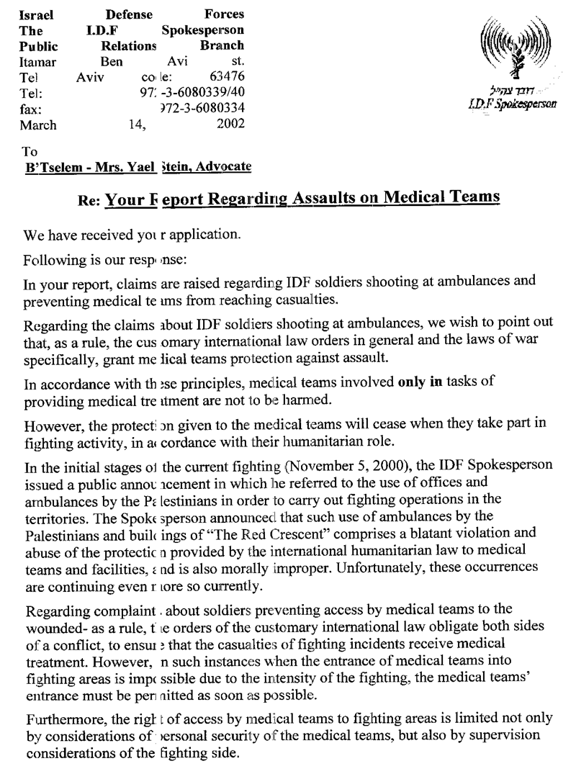
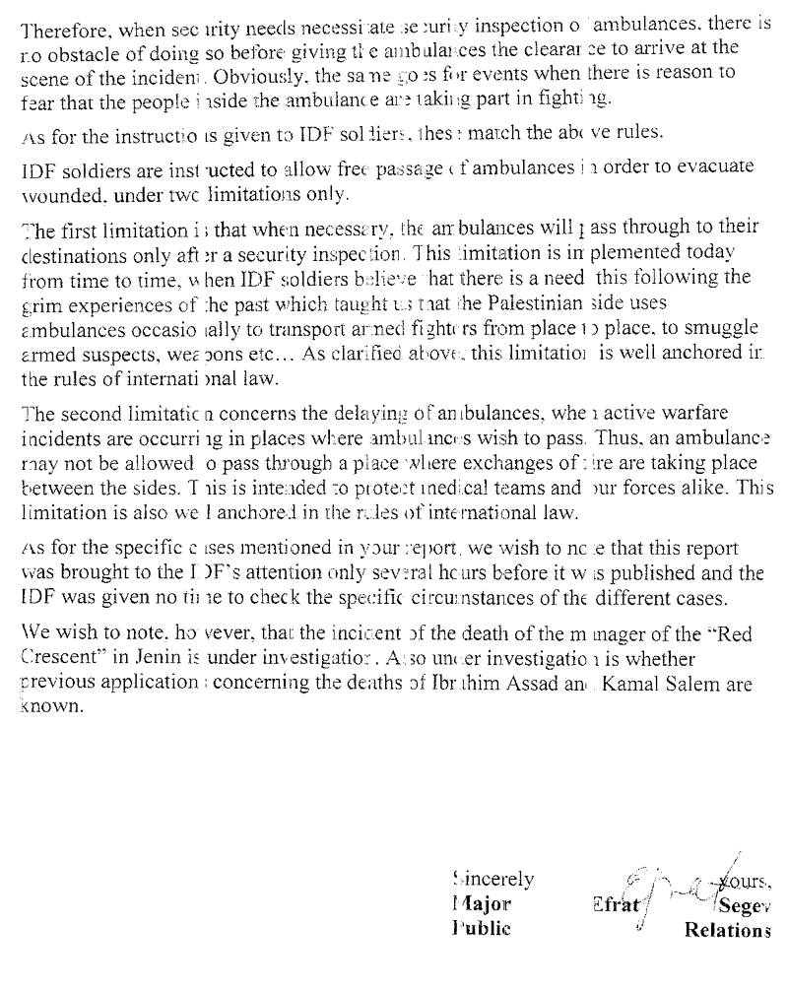

Statement of the IDF Spokesperson, 2 March 2002. For IDF releases, see www.idf.il
Statement of the IDF Spokesperson, 11 March 2002.
The information on the injuries to the Red Crescent was provided to B’Tselem on 19 March 2002.
See, for example, the Fourth Geneva Convention Relative to the Protection of Civilians in Wartime, articles 16-20.
See B’Tselem, No Way Out – Medical Implications of Israel’s Siege Policy, June 2001; B’Tselem, Excessive Force – Human Rights Violations during IDF Actions in Area A, pp. 33-36.
“Israel and the autonomous Territories: ICRC appeals for protection of medical staff,” Press Release, 8 March 2002. See also “Criticism of IDF Following Killing of Palestinian Medical-Team Personnel,” Ha’aretz, 10 March 02.
See, for example, B’Tselem, Illusions of Restraint – Human Rights Violations during the Events in the Occupied Territories, 29 September – 2 December 2000, December 2000, pp. 24-27.
The testimony was given to Najib Abu-Rokaya by telephone on 13 March 2002.
The testimony was given to ‘Ali Daragmeh on 28 February 2002.
The testimony was given to Nabil Makherez on 8 March 2002.
“Palestinian Sources: The Major Wanted Persons not Captured,” Ha’aretz, 10 March 2002.
Statement of the IDF Spokesperson, 4 March 2002.
The testimony of Dr. a-Rud was given to Musa Abu Hashhash on 6 March 2002. The testimony of Dr. Qadan was given to Najib Abu-Rokaya by telephone on 13 March 2002.
The testimony was given to Musa Abu Hashhash on 7 March 2002.
The testimony was given to Musa Abu Hashhash on 9 March 2002.
The testimony was given to Musa Abu Hashhash on 9 March 2002.
See B’Tselem, No Way Out. For more testimonies on this point, see B’Tselem’s Website: www.btselem.org.
The testimony was given to Musa Abu Hashhash on 12 March 2002.
The testimony was given to ‘Ali Daragmeh on 12 March 2002.
The testimony was given to Musa Abu Hashhash on 7 March 2002 at the Jenin Governmental Hospital.
The testimony was given to Najib Abu Rokaya by telephone on 17 March 2002. Some of these comments were made to B’Tselem by telephone on 13 March 2002 by Dr. Waal Qadan, director of the Red Crescent Society in the Occupied Territories.
Fourth Geneva Convention Relative to the Protection of Civilian Persons in Time of War, article 18.
Ibid., article 20.
Ibid., article 16.
Ibid., article 19.
Jean S. Pictet, Commentary on the Fourth Geneva Convention Relative to the Protection of Civilian Persons in Time of War (Geneva: International Committee of the Red Cross, 1958), p. 154.
Fourth Geneva Convention Relative to the Protection of Civilian Person in Time of War, articles 16 and 17; First Additional Protocol to the Geneva Conventions, of 12977, article 10.
HCJ 2117/02, Physicians for Human Rights v. Commander of IDF Forces in the West Bank et al.
Par. 17 of the state’s response.
Ibid.
Statement of the IDF Spokesperson, 2 March 2002.
Par. 20 of the state’s response.
B’Tselem, Illusions of Restraint, p. 43.
Statement of the IDF Spokesperson, 29 January 2002.
See, “The Pot Called the Kettle Black,” B’Tselem press release of 30 January 2002.
Pars. 15 and 17 of the state’s response.
Letter from the IDF Spokesperson’s office to B’Tselem, 9 March 2002.
The comments were made at his briefing on 24 October 2001. See the statement of the IDF Spokesperson of the same date.
See B’Tselem, Excessive Force, pp. 33-36.
Par. 18 of the state’s response.
On the Open-Fire Regulations during the al-Aqsa intifada, see B’Tselem, Trigger Happy: Unjustified Firing and the Open-Fire Regulations during the al-Aqsa Intifada, March 2002.
Par. 25 of the state’s response.
For similar cases, see, for example, B’Tselem, A Policy of Destruction: Demolition of Houses and Destruction of Agricultural Lawn in the Gaza Strip, February 2002; B’Tselem, Proposed Law – Imprisonment of Illegal Combatants, June 2002.

